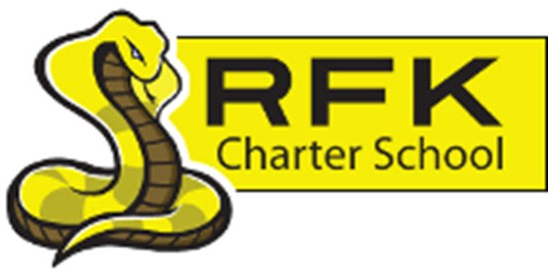

4300 Blake Rd. SW

Albuquerque, NM 87121

PHONE: 505-243-1118 FAX: 505-242-7444

PUBLIC NOTICE
OF
RFK GOVERNANCE COUNCIL MEETING

Robert F. Kennedy Charter School will hold a special meeting
of the Governance Council

Date
Monday, December 29, 2025

Time
4:30 PM

Location

4300 Blake Rd. SW
Albuquerque, NM 87121

If you are an individual with a disability who is in need of a reader, amplifier, qualified sign language interpreter or any other form of auxiliary aid or service to attend or participate in the meeting, please contact the administrative offices of RFK High School at least one week prior to the meeting or as soon as possible. Public documents, including the agenda and minutes, can also be provided in various accessible formats.
RFK High School Administrative offices – 505-243-1118

4300 Blake Rd. SW

Albuquerque, NM 87121

PHONE: 505-243-1118 FAX: 505-242-7444
Mission
RFK Charter School prepares, motivates, and supports students to achieve their college and career goals
in partnership with their families and the community.
Governance Council Special Meeting Agenda
Monday, December 29, 2025
4:30 PM
Time | Item | Presenter | Discussion/Action | Follow Up
4:30-4:35 | Roll Call | Mark Walch
4:35-4:40 | Approval of agenda | Mark Walch | Vote
4:40 -5:10 | Executive Session – to discuss personnel matters | Mark Walch | Vote
5:10-5:25 | Approval of Executive Director and CTE Director Contracts | Mark Walch | Vote
5:25-5:35 | Approval of Revised Policy and Procedures | Mark Walch/Irene Sanchez | Vote
5:35 | Adjourn | Mark Walch | Vote
Next meeting: January 22, 2026

