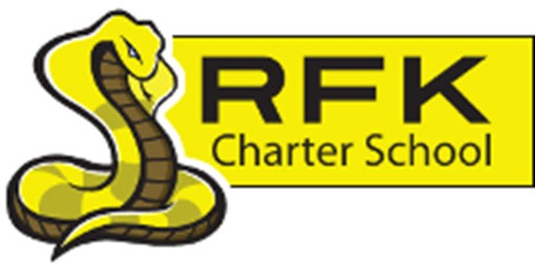

4300 Blake Rd. SW

Albuquerque, NM 87121

PHONE: 505-243-1118 FAX: 505-242-7444

PUBLIC NOTICE
OF
RFK GOVERNANCE COUNCIL MEETING

Robert F. Kennedy Charter School will hold a special meeting
of the Governance Council

Date
Saturday, December 06, 2025

Time
10:00 AM

Location
Special Collections Library

423 Central Ave. NE
Albuquerque, NM 87102

If you are an individual with a disability who is in need of a reader, amplifier, qualified sign language interpreter or any other form of auxiliary aid or service to attend or participate in the meeting, please contact the administrative offices of RFK High School at least one week prior to the meeting or as soon as possible. Public documents, including the agenda and minutes, can also be provided in various accessible formats.
RFK High School Administrative offices – 505-243-1118

4300 Blake Rd. SW

Albuquerque, NM 87121

PHONE: 505-243-1118 FAX: 505-242-7444
Mission
RFK Charter School prepares, motivates, and supports students to achieve their college and career goals
in partnership with their families and the community.
Governance Council Special Meeting Agenda
Saturday, December 06, 2025
10:00 AM
Time | Item | Presenter | Discussion/Action | Follow Up
10:00-10:05 | Roll Call | Mark Walch
10:05-10:10 | Approval of agenda | Mark Walch | Vote
10:10 -12:00 | Executive Session – to discuss personnel matters | Mark Walch | Vote
12:00 | Adjourn | Mark Walch | Vote
Next meeting: December 18, 2025

