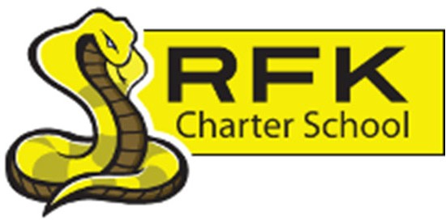

4300 Blake Rd. SW

Albuquerque, NM 87121

PHONE: 505-243-1118 FAX: 505-242-7444

PUBLIC NOTICE
OF
RFK GOVERNANCE COUNCIL MEETING

Robert F. Kennedy Charter School will hold a regular meeting
of the Governance Council

Date
Thursday, September 25, 2025

Time
6:00 PM

Location
RFK Charter High School

4300 Blake Rd. SW
Albuquerque, NM 87121

If you are an individual with a disability who is in need of a reader, amplifier, qualified sign language interpreter or any other form of auxiliary aid or service to attend or participate in the meeting, please contact the administrative offices of RFK High School at least one week prior to the meeting or as soon as possible. Public documents, including the agenda and minutes, can also be provided in various accessible formats.
RFK High School Administrative offices – 505-243-1118

4300 Blake Rd. SW

Albuquerque, NM 87121

PHONE: 505-243-1118 FAX: 505-242-7444
Mission
RFK Charter School prepares, motivates, and supports students to achieve their college and career goals
in partnership with their families and the community.
Governance Council Meeting Agenda
Thursday, September 25, 2025
6:00 PM
Time | Item | Presenter | Discussion/Action | Follow Up
6:00-6:05 | Roll Call | Mark Walch
6:05-6:10 | Approval of agenda | Mark Walch | Vote
6:10-6:15 | Approval of August 28, 2025 meeting minutes & September 11, 2025 Special meeting minutes | Mark Walch | Vote
6:15-6:25 | Public Comment – Sionna Grassbaugh, possible new board member | Mark Walch | Discussion
6:25-6:35 | Student Safety Policy | Robert Baade & Bob Edgar | Vote
6:35-6:45 | Approval of Strategic Plan | Mark Walch | Vote
6:45-6:55 | High School/Middle School Update | Aaron Arellano | Discussion
6:55-7:05 | Director’s Report | Holly Gurule | Discussion
7:05-7:15 | Approval of Charter Renewal – (minor modifications can be made without additional board approval) | Holly Gurule | Vote
7:15-7:30 | - Finance Committee report for August 2025 - discussion and approval  - Cash disbursement for August 2025  discussion and approval  - BAR(s) approval | Lawrence Barela/Irene Sanchez  Lawrence Barela/Irene Sanchez  Lawrence Barela/Irene Sanchez | Vote  Vote  Vote
7:30-7:40 | Middle School Transistion Report | Holly Gurule | Discussion
7:40-7:50 | Student engagement Report | Holly Gurule | Discussion
7:50-8:00 | Update on CTE Facility | Robert Baade | Discussion
8:00-8:10 | Dual Credit and CTE pathways update | Clyde Ortiz | Discussion
8:10-8:20 | Executive Directors Report | Robert Baade | Discussion
8:20-8:25 | Approve Holly Gurule as a check signer | Mark Walch | Vote
8:25 -8:30 | Housekeeping: training hours; Committee updates | Mark Walch | Discussion
8:30 | Adjourn | Mark Walch | Vote
Next meeting: October 23, 2025

