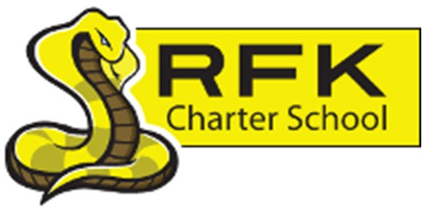

4300 Blake Rd. SW

Albuquerque, NM 87121

PHONE: 505-243-1118 FAX: 505-242-7444

PUBLIC NOTICE
OF
RFK GOVERNANCE COUNCIL SPECIAL MEETING

Robert F. Kennedy Charter School will hold a regular meeting
of the Governance Council

Date
Thursday, June 12, 2025

Time
5:00 PM

Location
High School
4300 Blake Rd. SW, Alb., NM 87121

If you are an individual with a disability who is in need of a reader, amplifier, qualified sign language interpreter or any other form of auxiliary aid or service to attend or participate in the meeting, please contact the administrative offices of RFK High School at least one week prior to the meeting or as soon as possible. Public documents, including the agenda and minutes, can also be provided in various accessible formats.
RFK High School Administrative offices – 505-243-1118

4300 Blake Rd. SW

Albuquerque, NM 87121

PHONE: 505-243-1118 FAX: 505-242-7444
Mission
RFK Charter School prepares, motivates, and supports students to achieve their college and career goals
in partnership with their families and the community.
Governance Council Special Meeting Agenda
Thursday, June 12, 2025
5:00 PM
Time | Item | Presenter | Discussion/Action | Follow Up
5:00-5:05 | Roll Call | Mark Walch
5:05-5:10 | Approval of agenda | Mark Walch | Vote
5:10-5:20 | Public Comment | Mark Walch | Discussion
5:20-5:45 | Executive Session – Personnel | Mark Walch | Discussion
5:45-6:00 | Personnel (Contracts) | Mark Walch | Vote
6:00 | Adjourn | Mark Walch | Vote
Next meeting: June 26, 2025

