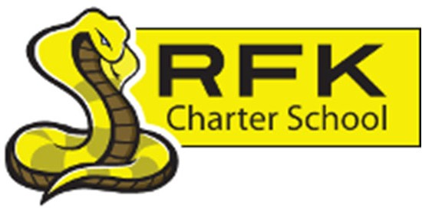
4300 Blake Rd. SW Albuquerque, NM 87121
PHONE: 505‐243‐1118 FAX: 505‐242‐7444

Mission
RFK Charter School prepares, motivates, and supports students to achieve their college and career goals in partnership with their families and the community.

Governance Council Meeting Minutes Thursday, July 27, 2023
4:30 p.m.

RFK GC Board President, Mark Walch called a regular GC Meeting at 4:32pm on Thursday, July 27, 2023.

All Board Members:
Mark Walch, President
April Gallegos, Secretary
Sylvia McCleary, Treasurer
Angel Garcia

Absent (excused):
Lawrence Barela, Vice President
Michele Coleman
Carlos Caballero
Trey Hammond
Denise Parras

Quorum:
No

Staff:
Robert Baade
Irene Sanchez
Aaron Arellano
Aradeli Ibarra

Approval of Agenda:
Sylvia McCleary made a motion to accept the July 27, 2023, GC Meeting Agenda. Angel Garcia seconded the motion. Due to no established quorum, a vote / action will take place in the Regular GC Open Meeting on August 17, 2023.

Approval of Meeting Minutes:
Sylvia McCleary made a motion to accept the July 27, 2023, Meeting Minutes. Mark Walch seconded the motion. Due to no established quorum, a vote / action will take place in the Regular GC Open Meeting on August 17, 2023.

Public Comment:
No Public Comment to report.

Finance Committee Report:
The Finance Committee Report was discussed and reviewed. Due to no established quorum, a vote / action will take place in the Regular GC Open Meeting on August 17, 2023.

Cash Disbursements for June 2023:
June 2023 Cash Disbursements were discussed and reviewed. Due to no established quorum, a vote / action will take place in the Regular GC Open Meeting on August 17, 2023.

BAR(s):
No Bar(s) to report.

GC Self Evaluation:
GC’s self-evaluation will take place on August 25th from 1pm to 4pm at The South Valley Economic Development Center.

Equity council update:
MS Principle, Aaron Arellano reports that the Equity Council will begin at the beginning of the year and will update the group as well as those who participate when needed.

Executive Director’s Report:
Executive Director, Robert Baade reported that the report was basically touched on within the entire meeting. He is also very excited to begin a new year and is hopeful of continuing as RFK Climbs up to a “School of First Choice”.

Housekeeping: training hours, planning meeting, updated website, Board term limits, etc.:
- Training hours have been completed by all “returning board members” as well as Angel Garcia and April Gallegos have all required training completed. Others who have not completed, will be contacted.

- GC Members are encouraged to reach out to the public for member opportunities.

Adjourn:
RFK GC Board President, Mark Walch adjourns at 6:12pm

Next meeting:
August 17, 2023

Minutes by:
RFK GC Board Secretary, April Gallegos
RFK MS Office Manager, Aradeli Ibarra

______________________________________________
Governance Council Secretary Signature

______________________________
Date

