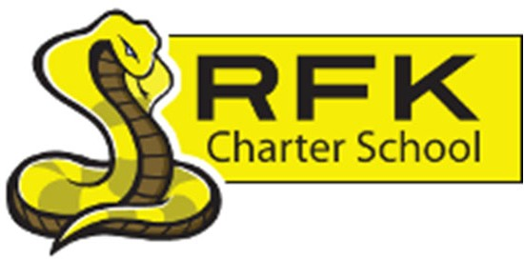
4300 Blake Rd. SW Albuquerque, NM 87121
PHONE: 505‐243‐1118 FAX: 505‐242‐7444
Mission
RFK Charter School prepares, motivates, and supports students to achieve their college and career goals in partnership with their families and the community.

Governance Council Meeting Minutes Thursday, November 17, 2022
4:30 p.m.

All council members:

Roll Call:
Mark Walch
Lawrence Barela
April Gallegos
Trey Hammond
Angel Garcia
Denise Parras

Zoom:
Katie Avery

Absent:
Sylvia McCleary
Michelle Coleman

Quorum: Yes

Staff:
Robert Baade
Irene Sanchez
Shawn Morris

Clyde Ortiz

Guests:
Carlos Caballeros

Approval of Agenda:

Lawrence Barela makes a motion to approve the November 17, 2022, Agenda with an addition to add “Term Limits” to the “housekeeping” section. Angel Garcia seconded the motion. The motion passed unanimously.

Approval of meeting minutes:
Lawrence Barela makes a motion to accept October 20, 2022, meeting minutes with corrections on the third page, “New GC Members” section. To state, “A conversation / interview will be held with Carlos Caballeros for membership to GC Board.” Angel Garcia seconded the motion. The motion passed unanimously.

Public Comment:

Clyde Ortiz, RFK’S CTE Coordinator reflected on the RFK CTE Proposed Career Pathways.

Katie Avery reports on “Local Profile of an RFK Graduate.

Middle School Update / High School Update:

HS Principal Shawn Morris spoke on behalf of both the MS and HS. Mr. Morris reports that the MS and HS students remain working with PB&J, Nature Ninos, and Cottonwood Gulch. With the near end of the 2022 semester and now that PED has done walkthroughs, there are some key factors on what needs to be assessed. Such as, faculty development to get teachers to make importance of directives. An example would be like when the students come in, there should be a learning objective to prepare for the day’s lesson. It also helps students prepare and when asked what they are working on he/she can reiterate. Another is to conduct student diagnostics when they arrive at RFK to help seek out appropriate methods in assisting with academics.

Student enrollment:

Middle School had seventy-nine students enrolled. High School has 291. With a total count of 370 students.

Finance Committee Report:

Lawrence Barela makes a motion to approve the Finance Report for October 2022. Angel Garcia seconded the motion. All in favor. Motion passes and carries.

Cash Disbursements:

Lawrence Barela made a motion to approve October 2022 Cash disbursements totaling, $637,014.18. Angel Garcia seconded the motion. All in favor. Motion passes and carries.

BARS: No bars to report.

Equity council:

Director, Robert Baade has been working with MS Principal, Aaron Arellano in developing an Equity Council. With plans to be up and running by early Spring of 2023.

Executive Director’s Report:

Director, Robert Baade reported on teacher observations, instructional leadership, and teacher development. In addition to dual enrollment and career education programs for the second semester as we move to a “School of First Choice”. Student enrollment and its relationship to school funding continues to be a concern as we approach the 80-day count.

New GC Members:

Lawrence Barela makes a motion to approve new GC board member, Carlos Caballero. April Gallegos seconded the motion. All in favor. Motion passes and carries. Welcome, Mr. Caballero!

Housekeeping:

GC members who have not finished their training are encouraged to get this done soon. Irene needs shirt sizes and Bios for the website.

Adjourn:

Lawrence Barela makes a motion to adjourn the meeting.

Mark Walch adjourns the meeting at 6:36 p.m.

Next meeting:

December 15, 2022.

Minutes by:

April Gallegos

