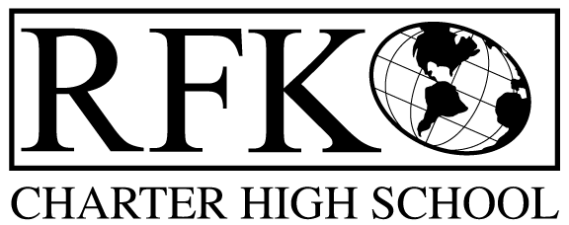

4300 Blake Rd. SW

Albuquerque, NM 87121

PHONE: 505-243-1118 FAX: 505-242-7444

PUBLIC NOTICE
OF
RFK GOVERNANCE COUNCIL MEETING

Robert F. Kennedy Charter School will hold a regular meeting
of the Governance Council

Date
Wednesday, June 22, 2022

Time
6:30 PM

Location
(Virtually – Zoom)
RFK Charter High School

4300 Blake Rd. SW
Albuquerque, NM

If you are an individual with a disability who is in need of a reader, amplifier, qualified sign language interpreter or any other form of auxiliary aid or service to attend or participate in the meeting, please contact the administrative offices of RFK High School at least one week prior to the meeting or as soon as possible. Public documents, including the agenda and minutes, can also be provided in various accessible formats.
RFK High School Administrative offices – 505-243-1118

4300 Blake Rd. SW

Albuquerque, NM 87121

PHONE: 505-243-1118 FAX: 505-242-7444

Mission
RFK Charter School prepares, motivates, and supports students to achieve their college and career goals
in partnership with their families and the community.
Governance Council Meeting Agenda
Wednesday, June 22, 2022
Special Meeting
6:30 PM
Time | Item | Presenter | Discussion/Action | Follow Up
6:30-6:35 | Roll Call | Mark Walch
6:35-6:40 | Approval of agenda | Mark Walch | Vote
6:40-6:55 | BAR(s) approval | Irene Sanchez/Sylvia | Vote
6:55 | Adjourn | Mark Walch | Vote
Next meeting: July 21, 2022 at 4:30 PM

