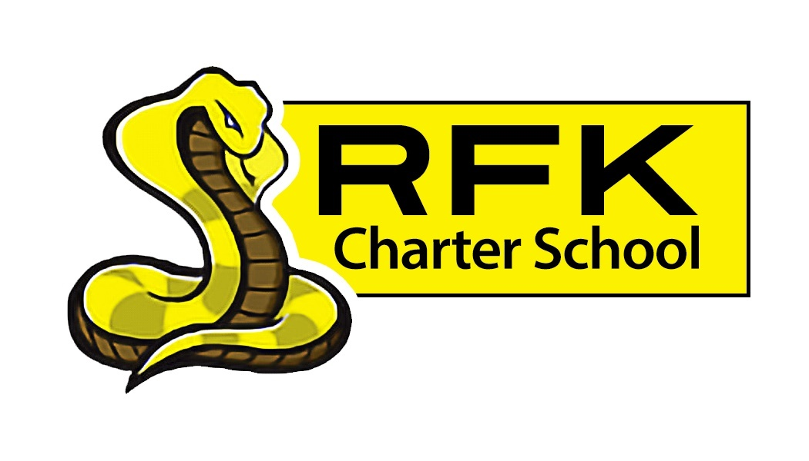

4300 Blake Rd. SW

Albuquerque, NM 87121

PHONE: 505-243-1118 FAX: 505-242-7444

PUBLIC NOTICE
OF
RFK GOVERNANCE COUNCIL MEETING

Robert F. Kennedy Charter School will hold a regular meeting
of the Governance Council

Date
Thursday, May 19, 2022

Time
4:30 PM

Location
RFK Charter High School

4300 Blake Rd. SW
Albuquerque, NM

If you are an individual with a disability who is in need of a reader, amplifier, qualified sign language interpreter or any other form of auxiliary aid or service to attend or participate in the meeting, please contact the administrative offices of RFK High School at least one week prior to the meeting or as soon as possible. Public documents, including the agenda and minutes, can also be provided in various accessible formats.
RFK High School Administrative offices – 505-243-1118

4300 Blake Rd. SW

Albuquerque, NM 87121

PHONE: 505-243-1118 FAX: 505-242-7444

Mission
RFK Charter School prepares, motivates, and supports students to achieve their college and career goals
in partnership with their families and the community.
Governance Council Meeting Agenda
Thursday, May 19, 2022
4:30 PM
Time | Item | Presenter | Discussion/Action | Follow Up
4:30-4:35 | Roll Call | Mark Walch
4:35-4:40 | Approval of agenda | Mark Walch | Vote
4:40-4:45 | Approval of April 21, 2022, Special Meeting on April 7, 2022 and Special Meeting on April 25, 2022 meeting minutes | Mark Walch | Vote
4:45-5:00 | Public Comment – Kati Avery Intro. | Robert Baade | Discussion
5:00-5:15 | Middle School Update – What’s going on, academic progress, & incoming of new staff | Aaron Arellano | Discussion
5:15-5:30 | High School Update - What’s going on, academic progress, & incoming of new staff | Shawn Morris | Discussion
5:30-5:40 | - Finance Committee report for April 2022 - discussion and approval  - Cash disbursement for April 2022 -  discussion and approval  - BAR(s) approval  - Disposal of Assets | Irene Sanchez/Sylvia  Irene Sanchez/Sylvia  Irene Sanchez/Sylvia  Irene Sanchez | Vote  Vote  Vote  Vote
5:40-5:45 | Lease Assistance | Irene | Vote
5:45-5:55 | Discussion about possible new board members | Mark Walch | Discussion
5:55-6:05 | Graduation Rates for 2022 | Robert Baade | Discussion
6:05-6:10 | Equity Council | Robert Baade | Discussion
6:10-6:25 | Executive Director’s Report | Robert Baade | Discussion
6:25-6:30 | Housekeeping (Any possible new members, training hours, planning meeting, etc.) | Mark Walch | Discussion
6:30 | Adjourn | Mark Walch | Vote
Next meeting: June 16, 2022 at 4:30 PM

