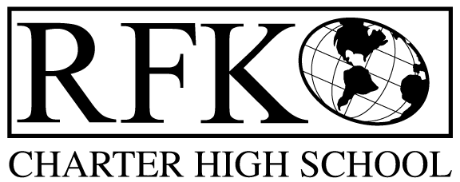

4300 Blake Rd. SW
Albuquerque, NM 87121
PHONE: 505-243-1118 FAX: 505-242-7444

Mission
RFK Charter School prepares, motivates, and supports students to achieve their college and career goals
in partnership with their families and the community.
Governance Council Meeting Minutes
Thursday October 21, 2021
4:30 PM

Governance Council Members:

Roll Call: Chair: Tina Garcia-Shams, Mark Walch, Sylvia McCleary, Lawrence Barela, Trey Hammond (virtual), Clyde Ortiz (virtual)

Absent: Joseph Sanchez
Yes: Quorum
Staff: Robert Baade, Irene Sanchez, Aaron Arellano, Shawn Morris

Guests: Representative Roybal-Caballero and Josie Marrujo with LULAC
Approval of agenda
Tina Garcia-Shams made the motion to approve the October agenda. Trey Hammond seconded. The motion passed unanimously

Approval September meeting minutes
Mark Walch motioned to approve the September 2021 meeting minutes. Sylvia McCleary seconded. The motion passed unanimously. *Approval pending requested corrections/changes

Public Comment – Representative Roybal-Caballero spoke about current items going on
Josie Marrujo with LULAC spoke about their current program

Middle School High School Update – Aaron Arellano provided the Middle School updates

High School Update - Shawn Morris provided the high school updates; stating that 361 total students are enrolled, with 270 at the high school.

Finance Committee Report
Vote: Lawrence Barela made the motion to approve the finance committee report for September. Sylvia McCleary seconded the motion. The motion passed unanimously.

Cash Disbursements – total of $498,066.95
Vote: Sylvia McCleary made a motion to approve the cash disbursement. Tina Gacia-Shams seconded the motion. The motion passed unanimously.

BARs
Sylvia McCleary made a motion to approve BAR # 001-051-2122-0021-IB Lease Assistance (initial budget), $249,253. Lawrence Barela seconded the motion. The motion passed unanimously.
Sylvia McCleary made a motion to approve the BAR #001-051-2122-0022-IB, DOH-Covid testing (initial budget), $81,100. Lawrence Barela seconded the motion. The motion passed unanimously.

Disposal of assets: Several student laptops, printers, desktops, monitors, etc.
Vote: Lawrence Barela made a motion to approve the cash disbursement. Sylvia McCleary seconded the motion. The motion passed unanimously.

RFR
- RFR submitted through September 30 2021.

Cash on hand – Months of cash on hand is 1.71 months
Enrollment count is 362 (268 High School, 94 Middle School) which stays within the budget of actual of 97%
Audit Findings – FY’2020
6 findings, 1 repeat finding.

Update on Financial Institution switch:
Sylvia McCleary gave a brief update on the process of switching banking institutions. Sylvia stated we would do the switch during the summer.

Housekeeping – talked about board training hours, possible new board members, possible new community members and different committees.

Executive Director’s Report - We have completed the initial APS site visit for the year this morning with Dr. Escobedo visiting classrooms, in addition to Special Education and Financial reviews.
The visit was extremely positive and it was acknowledged how well prepared we were for the visit on all fronts. We continue to enroll students of choice and hire short term staff to cover all the holes that the current environment creates on a weekly sometimes daily basis. We anticipate a reduction for the 40 day count of appx. $125,000. We have begun conversations with legislators and anticipate requests totaling $450,000 in capital and potential operating funds.
After a conversation with our minutes taker our contract will not continue and my recommendation is to leave the schedule of Governance Council meetings as is and the minutes be taken as we look for another person to attend for the purpose.
At this point in time I am withdrawing my hard deadline of retiring at the end of next year. Corvid has clearly disrupted the planned transition, combined with the change in direction indicated by this Council and its connection to the work with Casey Foundation and John Hopkins. I want to support the transition and leaving at the end of next year may not be the ideal plan at this time.

Adjourn
Vote: Mark Walch made the motion to adjourn. Sylvia McCleary seconded. The motion passed unanimously
Adjourned at 7:14pm

Robert F Kennedy Charter School
Governance Council Meeting
10/21/2021

