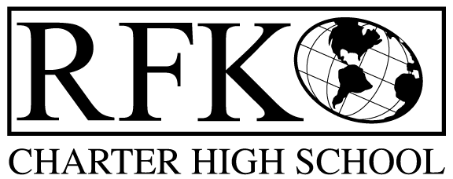

4300 Blake Rd. SW
Albuquerque, NM 87121
PHONE: 505-243-1118 FAX: 505-242-7444

Mission
RFK Charter School prepares, motivates, and supports students to achieve their college and career goals
in partnership with their families and the community.
Governance Council Meeting Minutes – Special Meeting
Thursday, July 29, 2021 5:30 PM (Virtual meeting)

Governance Council Members all virtual:
Roll Call (5:31pm): Chair: Clyde Ortiz, Mark Walch, Tina Garcia-Shams, Sylvia McCleary, Lawrence Barela and Stacey Vigil

Absent: Trey Hammond, , and Joseph Sanchez

Staff: Robert Baade, Irene Sanchez, and Shawn Morris
Minutes by: Irene Sanchez

Approval of agenda
Sylvia McCleary motioned to approve the July 29, 2021 agenda. Lawrence Barela seconded. The motion is unanimously approved.

BARs:

BAR# 001-051-2122-0002-IB, Fund 24312 – $17,574 Crrsa – Retention Stipends. Sylvia McCleary made a motion to approve, Tina Garcia-Shams seconded the motion. The motion has passed unanimously.

Meeting adjourned (5:54pm)
Sylvia McCleary made a motion to adjourn the meeting. Stacey Vigil seconded the motion. The motion passed unanimously.

Robert F Kennedy Charter School
Governance Council Meeting
07/29/2021

