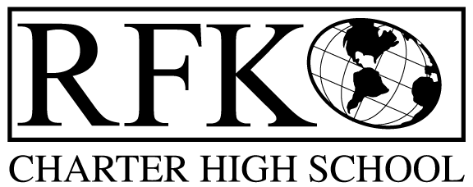

4300 Blake Rd. SW
Albuquerque, NM 87121
PHONE: 505-243-1118 FAX: 505-242-7444

Mission
RFK Charter School prepares, motivates, and supports students to achieve their college and career goals
in partnership with their families and the community.
Governance Council Meeting Minutes – Special Meeting
Thursday, June 10, 2021 12:00 PM (Virtual meeting)

Governance Council Members all virtual:
Roll Call (12:07pm): Chair: Tina Garcia: Clyde Ortiz, Mark Walch, Tina Garcia-Shams, Joseph Sanchez, and Stacey Vigil
Absent: Trey Hammond, Sylvia McCleary, and Lawrence Barela

Staff: Robert Baade, Irene Sanchez, Shawn Morris and Aaron Arellano
Minutes by: Irene Sanchez

Approval of agenda
Mark Walch motioned to approve the June 10 ,2021 agenda with the removal of the Director’s Contract Action and move to meeting 6/17/21. Tina Garcia-Shams seconded. The motion is unanimously approved.

BARs:

BAR# 001-051-2021-0043-IB, Fund 24176 – $16,736 CTE. Joseph Sanchez made a motion to approve, Tina Garcia-Shams seconded the motion. The motion has passed unanimously.
BAR# 001-051-2021-0044-I, Fund 29102 – $1,500 East Central Ministries – Donation to help with Food Distribution. Joseph Sanchez made a motion to approve, Tina Garcia-Shams seconded the motion. The motion has passed unanimously.

Meeting adjourned (12:11pm)
Mark Walch made a motion to adjourn the meeting. Tina Garcia-Shams seconded the motion. The motion passed unanimously.

Robert F Kennedy Charter School
Governance Council Meeting
06/10/2021

