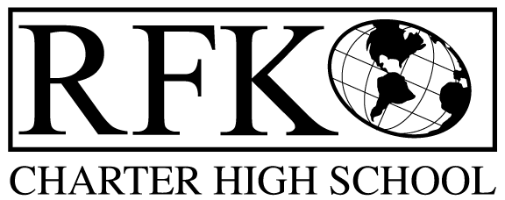

4300 Blake Rd. SW
Albuquerque, NM 87121
PHONE: 505-243-1118 FAX: 505-242-7444

Mission
RFK Charter School prepares, motivates, and supports students to achieve their college and career goals
in partnership with their families and the community.
Governance Council Meeting Minutes – Special Meeting
Monday, May 05, 2021 5:30 PM (Virtual meeting)

Governance Council Members all virtual:
Role Call (5:37pm): Chair: Tina Garcia: Lawrence Barela, Clyde Ortiz, Mark Walch, and Tina Garcia-Shams
Absent: Joseph Sanchez, Trey Hammond, Silvia McCleary, and Stacey Vigil

Staff: Robert Baade, Irene Sanchez, Shawn Morris
Minutes by: Irene Sanchez

Approval of agenda
Lawrence Barela motioned to approve the May 02 ,2021 agenda. Mark Walch seconded. The motion is unanimously approved.

BARs:

BAR# 001-051-2021-0034-I, Fund 24101 – $5,000 Title I – Supplies to Help Reopen - . Mark Walch made a motion to approve, Tina Garcia-Shams seconded the motion. The motion has passed unanimously.

Teacher Salary Schedule for FY’22 – Tina Garcia-Shams made a motion to approve, Mark Walch seconded the motion. The motion has passed unanimously.
- Similar to APS Salary Schedule
- Includes 1.50% increase
- Increase is given to all employees

Meeting adjourned (6:03pm)
Lawrence Barela made a motion to adjourn the meeting. Mark Walch seconded the motion. The motion passed unanimously.

Robert F Kennedy Charter School
Governance Council Meeting
05/03/2021

