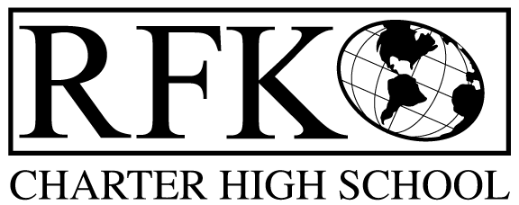

4300 Blake Rd. SW
Albuquerque, NM 87121
PHONE: 505-243-1118 FAX: 505-242-7444

Mission
RFK Charter School prepares, motivates, and supports students to achieve their college and career goals
in partnership with their families and the community.
Governance Council Meeting Minutes
Tuesday, January 21, 2020 2:00 PM
Special Meeting

Governance Council Members present (by Phone): Tina Garcia, Sister Agnes Kaczmarek, Lawrence Barela, Beverly Nomberg (absent), Stacey Vigil (absent), Wendy Shanahan, Tina Garcia-Shams
Staff: Robert Baade, Irene Sanchez,
Minutes by: Irene Sanchez

Wendy Shanahan motioned to approve the January 21, 2020 (Special Meeting) Agenda with removal of everything except the approval of BARs. Sister Agnes Kaczmarek seconds. The motion is unanimously approved. The motion was passed

Public Comments
N/A
Vote on New GC member
N/A

Finance Committee Report- December 2019

N/A

Revenues for December 2019

N/A

Cash Disbursement Approval-

N/A

Questions regarding expenses

N/A

RFR
N/A
January BAR (s)
BAR# 001-051-1920-0021-Initial Budget, Fund 27127 - $150,000 - Community Schools - Lawrence Barela moved to approve, Wendy Shanahan seconded the motion. The motion passed unanimously
BAR# 001-051-1920-0022-Decrease, Fund 28133 – ($18,869) - Y.C.C. - Lawrence Barela moved to approve, Wendy Shanahan seconded the motion. The motion passed unanimously
BAR# 001-051-1920-0023-Increase, Fund 28133 – $104,769 - Y.C.C. - Lawrence Barela moved to approve, Wendy Shanahan seconded the motion. The motion passed unanimously

Cash on hand – N/A

Audit findings the same
N/A
Director’s Report-

N/A

Lawrence Barela moves to adjourn the meeting and Sister Agnes Kaczmarek seconds. The motion passed unanimously.

Meeting adjourned at 2:20 pm

Next Meeting: February 20, 2020 5:30 pm

Robert F Kennedy Charter School
Governance Council Meeting
01/21/2020

