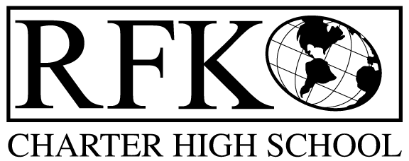

4300 Blake Rd. SW
Albuquerque, NM 87121
PHONE: 505-243-1118 FAX: 505-242-7444

Mission
RFK Charter School prepares, motivates, and supports students to achieve their college and career goals
in partnership with their families and the community.
Governance Council Special Meeting Minutes
Tuesday, November 05, 2019 11:00 AM

Governance Council Members present: Tina Garcia, Ron Burton(on the phone), Sister Agnes Kaczmarek (on the phone), Wendy Shanahan (on the phone)
Staff: Robert Baade, Irene Sanchez
Minutes by: Irene Sanchez
Absent: Lawrence Barela
Ron Burton motioned to approve the November 2019, Special Meeting, Agenda. Sister Agnes Kaczmarek seconds. The motion is unanimously approved.

BAR (s)
BAR# 001-051-1920-0011-I, Fund 24101, Title I increase of $20,076
Wendy Shanahan moved to approve, Ron Burton seconded the motion. The motion passed unanimously

BAR# 001-051-1920-0012-I, Fund 27103, Dual Credit increase of $6,806
Wendy Shanahan moved to approve, Ron Burton seconded the motion. The motion passed unanimously

BAR# 001-051-1920-0013-I, Fund 14000, Instructional Materials carryover of $3,630
Wendy Shanahan moved to approve, Ron Burton seconded the motion. The motion passed unanimously

BAR# 001-051-1920-00014-I, Fund 31701, SB-9 carryover of $5,342
Wendy Shanahan moved to approve, Ron Burton seconded the motion. The motion passed unanimously

BAR# 001-051-1920-00015-I, Fund 21000, Food Service carryover of $601
Wendy Shanahan moved to approve, Ron Burton seconded the motion. The motion passed unanimously

BAR# 001-051-1920-00016-IB, Fund 27502, Career Technical Education initial budget of $8,000
Wendy Shanahan moved to approve, Ron Burton seconded the motion. The motion passed unanimously

BAR# 001-051-1920-00017-IB, Fund 26186, ABC Community Partner-OST initial budget of $12,000
Wendy Shanahan moved to approve, Ron Burton seconded the motion. The motion passed unanimously

Ron Burton moves to adjourn the meeting and Sister Agnes Kaczmarek seconds. The motion passed unanimously.

Meeting adjourned at 11:15am

Next Meeting: November 21, 2019 5:30pm

Robert F Kennedy Charter School
Governance Council Meeting
10/17/2019

