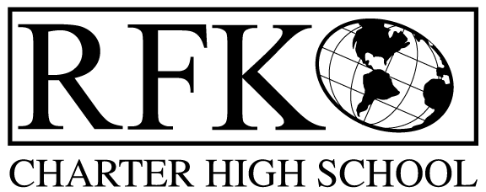

4300 Blake Rd. SW
Albuquerque, NM 87121
PHONE: 505-243-1118 FAX: 505-242-7444

Mission
RFK Charter School prepares, motivates, and supports students to achieve their college and career goals
in partnership with their families and the community.
Governance Council Special Meeting Minutes
Monday, May 27, 2019 8:30 AM

Governance Council Members present: Margie Lockwood, Sister Agnes Kaczmarek (called-in), Tina Garcia
Absent: Ron Burton, Wendy Shanahan
Staff: Robert Baade, Irene Sanchez
Guests: none
Minutes by: Irene Sanchez

Tina Garcia motioned to approve the May 27, 2019 Agenda. Sister Agnes Kaczmarek seconds. The motion is unanimously approved.

Public Comment - none

Finance Committee Report- none

BAR (s)-
- BAR# 001-051-1819-0019-I, Fund 31701 – SB-9 Cash Carryover – increase of $6,227
Tina Garcia moved to approve BAR# 001-051-1819-0019-I. Sister Agnes Kaczmarek seconded the motion. The motion passed unanimously

Tina Garcia moves to adjourn the meeting and Sister Agnes Kaczmarek seconds. The motion passed unanimously.

Meeting adjourned at 8:56 am
Robert F Kennedy Charter School
Governance Council Meeting –
Next meeting June 20th , 2019 5:30-7:00
05/27/2019

