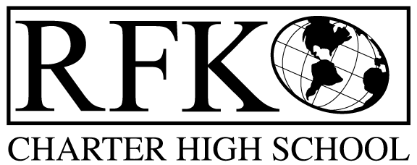

4300 Blake Rd. SW
Albuquerque, NM 87121
PHONE: 505-243-1118 FAX: 505-242-7444

Mission
RFK Charter School prepares, motivates, and supports students to achieve their college and career goals
in partnership with their families and the community.
Governance Council Meeting Minutes
Thursday, April 18, 2019 5:30 PM

Governance Council Members present: Margie Lockwood, Sister Agnes Kaczmarek, Ron Burton, Tina Garcia Wendy Shanahan,
Absent: Sister Agnes Kaczmarek
Staff: Robert Baade, Irene Sanchez, Liz Franco
Guests: students from YCC were introduced (students signed in)- Rafael Ruiz, Christina Patino, Danny Ramirez, Jose Chavez, Salvador Silos, Alonzo Fair, Serenity Sancho, Serenity Candelaria, Alex Ibarra, Alena Valverda, Elizabeth Franco
Minutes by: Anne Tafoya

Ron Burton motioned to approve the April 2019 Agenda. Tina Garcia seconds. The motion is unanimously approved.

Ron Burton motioned to approve the March 21, 2019 meeting minutes and Tina Garcia seconds. *With corrections noted and made by Anne Tafoya the motion is unanimously approved.
- Public Comment
- Students spoke on why they wanted to participate in the YCC program
- Good attendance in the YCC program is very important

Finance Committee Report- March 31, 2019

Ron Burton moved to approve the financial report and cash disbursement for March 2019. Wendy Shanahan seconds the approval of the financial report. The motion passed unanimously

Revenues for March 2019

- Available Operating Funds
  - As of March,2019, Available Operating Funds $25,825.34
- Balance Sheet matches Bank reconciliation $173,809.14
  - The amount matches
  - Bank balance $236,122.48
- Cash Disbursement Approval- $373,844.42

RFR
- Have been submitted through March 31, 2019
- Legislative appropriations
- Lease assistance

March BAR (s)- None to approve for March
Cash on hand –1.3 months of cash
Student Enrollment
- Enrollment 356 students 120 day
Audit Finding
- 5 findings from Fiscal year 2018
- Procedures are being put in place to address the Corrective actions
- Goal is to be in compliance
- Meeting to review CAPS will be on April 23rd at 8 pm
Disposal of property
- Portable radio tower
  - Will be selling it (looking market value comparison for selling price)

Ron Burton moved to approve the disposal of the tower. Tina Garcia seconded the motion. The motion passed unanimously

Discussion, approval of 2019-20 Budget and School Calendar
- Total budget available $3,696,709.84
- Increase in teacher salaries
- Budget is balanced
- Budget is due April 19th to PED and then will go to APS
- An explanation was given on how the budget will be affected when expected funding comes through
- Unit Value has increased which impacts teacher salaries
- Small School funding phase out is at 0.20 for the coming budget year- impacts operations
Wendy moves to approve the 2019-2020 budget. Ron Burton seconded the motion. The motion passed the unanimously.

School Calendar
- First day of new school year will August 8th, 2019
- Total extended school days is 12 – June 15-30,2020- separate contract
- Total of 190 contract days for the teachers
Ron Burton moved to approve the 2019-2020 calendar. Wendy Shanahan seconded the motion. The motion passed unanimously.

Director’s Report-
- PARCC testing next week
2 days at HS, 2 days at MS
- YCC has started- students have been hired
- Graduation May 24 at 4:00 pm at UNM Continuing Education building
- Professional Development for teachers- (additional 3 days)
- Applied for Extended Education Year Funding through PED

Other business
- Governance Council has been encouraged to recruit new council members
- Katy Duhigg had to resignfrom the council
- Discussions on times and locations of board trainings
- Can do online trainings- Irene will set up board members with log ins. Certificates will be issued once module is completed

Ron Burton moves to adjourn the meeting and Tina Garcia seconds. The motion passed unanimously.

Meeting adjourned at 7:20
Robert F Kennedy Charter School
Governance Council Meeting –
Next meeting May 16th , 2019 5:30-7:00
04/18/2019

