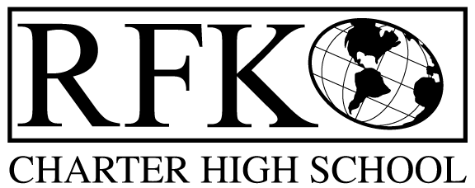

4300 Blake Rd. SW

Albuquerque, NM 87121

PHONE: 505-243-1118 FAX: 505-242-7444

Mission
RFK Charter School prepares, motivates, and supports students to achieve their college and career goals
in partnership with their families and the community.
Governance Council Meeting Agenda
Thursday, May 16, 2019
5:30 PM

Time | Item | Presenter | Discussion/Action | Follow Up
5:30-5:35 | Approval of agenda |  | Vote
5:35-5:40 | Approval of April 18, 2019 meeting minutes |  | Vote
5:40-5:45 | Announcements
5:45-6:00 | Public comment  DECA students - report on trip to Florida
6:00-6:20 | - Finance Committee report, cash disbursement for April, 2019– discussion and approval  - BAR(s) approval | Irene Sanchez | Vote  Vote
6:20-6:30 | Revised Fiscal Management Policies and Procedures | Irene Sanchez | Vote
6:30-6:40 | Graduation | Robert Baade
6:40-6:55 | Executive Director’s report | Robert Baade
6:55 | Adjourn |  | Vote

Next meeting: June 20, 2019
Graduation: May 24, 2019, 4:00 PM, UNM Continuing Education Building Auditorium
Last day of school: May 24, 2019

4300 Blake Rd. SW

Albuquerque, NM 87121

PHONE: 505-243-1118 FAX: 505-242-7444

PUBLIC NOTICE
OF
RFK GOVERNANCE COUNCIL MEETING

Robert F. Kennedy Charter School will hold a regular meeting
of the Governance Council

Date
Thursday, May 16, 2019

Time
5:30 PM

Location
RFK Charter High School

4300 Blake Rd. SW
Albuquerque, NM

If you are an individual with a disability who is in need of a reader, amplifier, qualified sign language interpreter or any other form of auxiliary aid or service to attend or participate in the meeting, please contact the administrative offices of RFK High School at least one week prior to the meeting or as soon as possible. Public documents, including the agenda and minutes, can also be provided in various accessible formats.
RFK High School Administrative offices – 505-243-1118

