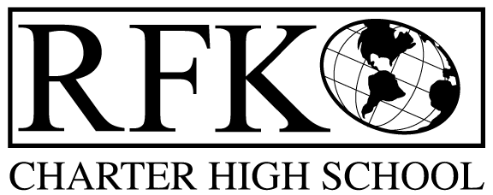

4300 Blake Rd. SW
Albuquerque, NM 87121
PHONE: 505-243-1118 FAX: 505-242-7444

Mission
RFK Charter School prepares, motivates, and supports students to achieve their college and career goals
in partnership with their families and the community.
Governance Council Meeting Minutes
Thursday, February 21, 2019 5:30 PM

Governance Council Members present: Margie Lockwood, Sister Agnes Kaczmarek, Wendy Shanahan, Ron Burton, Tina Garcia
Absent: Katy Duhigg
Staff: Robert Baade, Irene Sanchez
Guest: Ben McCracken. 2 ceramic students- Serenity and Adrien
Minutes by: Anne Tafoya

Ron Burton motioned to approve the February, 2019 Agenda. Wendy Shanahan seconds. The motion is unanimously approved. *A few edits were made to the agenda- Attendance, behavior, retention report and student engagement report will be added to next meeting.

Ron Burton motioned to approve the January 24, 2019 meeting minutes and Wendy Shanahah seconds. The motion is unanimously approved. *Add date fiscal year 2017 audit finding of 1
- Public Comment
  - Ben McCracken presented the ceramic program and how it aligns with RFK’s mission
  - Mr. McCracken reported on the success of a former RFK student
  - Mr. McCracken explained the curriculum of the ceramic class
  - The ceramic students spoke about the program and how it has impacted them
Margie presented the PED input survey-deadline is February 28
- Margie will send out the email with links again
Finance Committee Report- January 2019

Ron Burton moved to approve the financial report and cash disbursement for January 2019. Wendy Shanahan seconds the approval of the financial report. The motion passed unanimously

Revenues for January 2019

- Available Operating Funds
  - As of January 31,2019, Operating Fund $50,787.96
- Balance Sheet matches Bank reconciliation $242,998.54
  - The amount matches
- Cash Disbursement Approval- $325,310.17
  - Interfaith Education Fund expense was explained
RFR
- Will be submitted through January 31, 2019
  - Lease assistance was submitted with approval
January BAR
Ron Burton moved to approve BAR 001-051-1819-0009-I (Fund 24106 IDEA). Tina Garcia seconded the motion. The motion passed unanimously
Cash on hand –1.01 months of cash
Student Enrollment
- Enrollment 356 students
Audit Finding
- Only 1 finding from Fiscal year 2017
Cash Transfer Request
Wendy Shanahan moved to approve cash transfer request of 43 cents, 31 cents and 9 cents. Ron Burton seconded the motion. The motion passed unanimously
GC Training Progress Report
- Margie earned 2 hours of training put on by the state (reauthorization training)
- Online training is available
Board members up for reelection will added to March agenda
- Sister Agnes Kaczmarek
Legislative Report- Robert Baade presented- see attachment

Director’s Report- see attachment

- Dr. Escobedo will do a site visit in March 27^{th-} at 10:30 GC members are invited

Next meeting- March 20, 2019 5:30

Ron Burton moves to adjourn the meeting and Sister Agnes Kaczmarek seconds. The motion passed unanimously.

Meeting adjourned at
Robert F Kennedy Charter School
Governance Council Meeting
02/21/2019

