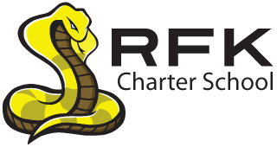
PARENT NOTIFICATION LETTER

(In Accordance with Every Student Succeeds Act, Title 1, Part A, Section 1112,
Parent Right to Know)

Date: October 2, 2018

Dear Parent:

On December 10, 2015, President Obama signed the new federal education act, titled
Every Student Succeeds Act. This new law includes many new programs and changes
for all public schools in the United States.

The new laws permit you, as a parent or guardian, the right to request information about the licensure, other qualifications and teaching assignments of your child’s teacher and any paraprofessional (instructional assistants) who may work with your child.

If you are interested in requesting this information, please contact

___Irene Sanchez___________ at _____505-873-1165_________________.

Sincerely,

Raquel Reedy
Superintendent
Albuquerque Public Schools

