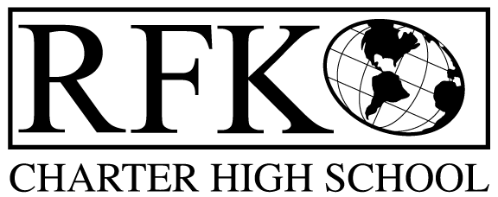

4300 Blake Rd. SW

Albuquerque, NM 87121

PHONE: 505-243-1118 FAX: 505-242-7444

Mission
RFK Charter School prepares, motivates, and supports students to achieve their college and career goals
in partnership with their families and the community.
Governance Council Meeting Agenda
Thursday, September 20, 2018
5:30 PM

Time | Item | Presenter | Discussion/Action | Follow Up
5:30-5:35 | Approval of agenda |  | Vote
5:35-5:40 | Approval of August 16, 2018 meeting minutes |  | Vote
5:40-5:45 | Announcements
5:45-6:00 | Public comment
6:00-6:15 | Middle School transition report | Lawrence Torres
6:15-6:30 | Attendance, behavior, retention report | Pete Ciurczak
6:30-7:00 | School grade, and 90 day improvement plan discussion | Linda Sanchez
7:00-7:25 | - Finance Committee report, cash disbursement for July– discussion and approval  - BAR(s) approval | Irene Sanchez | Vote  Vote
7:25-7:40 | Executive Director’s report (report card, ed. offerings for this year) | Robert Baade
7:40 | Adjourn |  | Vote

Next meeting: October 18, 2018
Audit Committee meeting with auditors: October 12, 2018 (time and place to be announced)
Albuquerque Interfaith forum to be held at RFK: September 23, 2018, 3-5:30 PM

4300 Blake Rd. SW

Albuquerque, NM 87121

PHONE: 505-243-1118 FAX: 505-242-7444

PUBLIC NOTICE
OF
RFK GOVERNANCE COUNCIL MEETING

Robert F. Kennedy Charter School will hold a regular meeting
of the Governance Council

Date
Thursday, September 20, 2018

Time
5:30 PM

Location
RFK Charter High School

4300 Blake Rd. SW
Albuquerque, NM

If you are an individual with a disability who is in need of a reader, amplifier, qualified sign language interpreter or any other form of auxiliary aid or service to attend or participate in the meeting, please contact the administrative offices of RFK High School at least one week prior to the meeting or as soon as possible. Public documents, including the agenda and minutes, can also be provided in various accessible formats.
RFK High School Administrative offices – 505-243-1118

