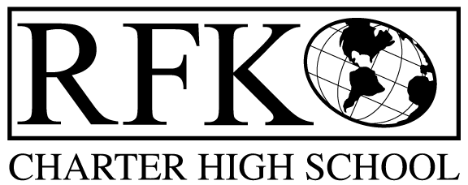

4300 Blake Rd. SW

Albuquerque, NM 87121

PHONE: 505-243-1118 FAX: 505-242-7444

Mission
RFK Charter School prepares, motivates, and supports students to achieve their college and career goals
in partnership with their families and the community.
Governance Council Meeting Agenda
Thursday, February 21, 2019
5:30 PM

Time | Item | Presenter | Discussion/Action | Follow Up
5:30-5:35 | Approval of agenda |  | Vote
5:35-5:40 | Approval of January 24, 2018 meeting minutes |  | Vote
5:40-5:45 | Announcements
5:45-6:00 | Public comment
6:00-6:15 | Attendance, behavior, retention report | Pete Ciurczak
6:15-6:30 | Student engagement report | Pete Ciurczak
6:30-6:45 | Finance Training – | Irene Sanchez
6:45-7:00 | - Finance Committee report, cash disbursement for January– discussion and approval  - BAR(s) approval  - Permanent Cash Transfer | Irene Sanchez | Vote  Vote  Vote
7:00-7:05 | GC Training Progress Report | Margie Lockwood
7:05-7:20 | Legislative Update | Robert Baade
7:20-7:35 | Executive Director’s report | Robert Baade
7:35 | Adjourn |  | Vote

Next meeting: March 21, 2019
Spring Break: March 11 – 15, 2019

4300 Blake Rd. SW

Albuquerque, NM 87121

PHONE: 505-243-1118 FAX: 505-242-7444

PUBLIC NOTICE
OF
RFK GOVERNANCE COUNCIL MEETING

Robert F. Kennedy Charter School will hold a regular meeting
of the Governance Council

Date
Thursday, February 21, 2019

Time
5:30 PM

Location
RFK Charter High School

4300 Blake Rd. SW
Albuquerque, NM

If you are an individual with a disability who is in need of a reader, amplifier, qualified sign language interpreter or any other form of auxiliary aid or service to attend or participate in the meeting, please contact the administrative offices of RFK High School at least one week prior to the meeting or as soon as possible. Public documents, including the agenda and minutes, can also be provided in various accessible formats.
RFK High School Administrative offices – 505-243-1118

