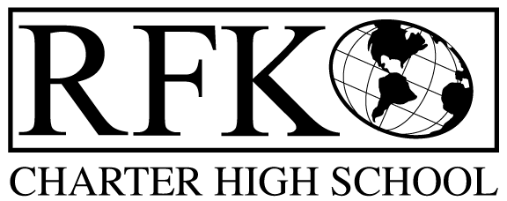

4300 Blake Rd. SW, Albuquerque, NM 87121

PHONE: 505-243-1118/FAX: 505-242-7444

Vision

“RFK, a school where you can engage in your chosen path towards secondary education or career in an environment that prepares, motivates, and supports you in partnership with your family.”

Mission

“This year we will improve teacher and student performance through a supportive and responsible environment.”

Governance Council Meeting Agenda

Wednesday, February 18, 2015 5:30pm

5 min Approval of Agenda

10 min Approval of February 2014 minutes

10 min Public Comment

20 min Finance Committee

finance report and approval

Cash Disbursement approval

BAR approval

10 min Board Secretary election

15 min credit acquisition report (Ken)

10 min set date for board training

20 min strategic plan revision report (Margie and Jennifer)

10 min Executive Director report

Adjournment

4300 Blake Rd. SW

Albuquerque, NM 87121

PHONE: 505-243-1118 FAX: 505-242-7444

PUBLIC NOTICE

OF

GOVERNANCE COUNCIL

MEETING

Robert F. Kennedy Charter School will hold a

regular monthly meeting of it’s Governance Council

Date

Wednesday, February 18, 2015

Time

5:30 pm

Location

RFK Charter School

4300 Blake Road SW

Albuquerque, NM

