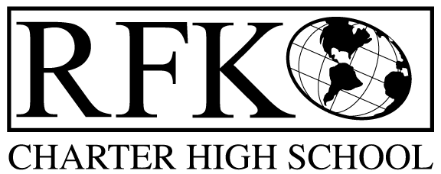

4300 Blake Rd. SW, Albuquerque, NM 87121

PHONE: 505-243-1118/FAX: 505-242-7444

Mission
RFK Charter School prepares, motivates, and supports students to achieve their college and career goals in partnership with their families and the community.

Governance Council Meeting Agenda

Thursday, August 18, 2016 5:30pm

Time | Item | Presenter | Discussion/Action | Follow Up
5 min | Approval of Agenda | Jennifer Cornish | Vote
10 min | Approval of July 2016 minutes | Jennifer Cornish | Vote
15 min | Public Comment | Guests | Discussion
15 min | Finance Committee Report  - July finance reports and approval  - Cash disbursement approval  - BAR approval | Ron Burton and Judy Bergs | Vote  Vote  Vote
10 min | Audit Report and discussion | Robert Baade and Judy Bergs | Discussion
10 min | Teacher Effectiveness report | Linda Sanchez | Discussion
10 min | Attendance, Behavior and Retention report | Pete Ciusrscak | Discussion
10 min | Credit Acquisition report | Margie Lockwood | Discussion
15 min | GC Self Evaluation report | Jennifer Cornish and Margie Lockwood | Discussion
5 min | GC meeting schedule vote | Jennifer Cornish | Vote
15 min | GC President position nomination and vote | Jennifer Cornish | Vote
10 min | Renewal of Jennifer Cornish’s GC membership | Margie Lockwood | Vote
15 min | Executive Director report (includes report on Educational Offerings for 2016-17) | Robert Baade | Discussion
 | Adjournment

4300 Blake Rd. SW

Albuquerque, NM 87121

PHONE: 505-243-1118 FAX: 505-242-7444

PUBLIC NOTICE

OF

RFK GOVERNANCE COUNCIL

MEETING

Robert F. Kennedy Charter School will hold the annual meeting

of the Governance Council

Date

Thursday, August 18, 2016

Time

5:30 pm

Location

RFK Charter School

4300 Blake SW

Albuquerque, NM

