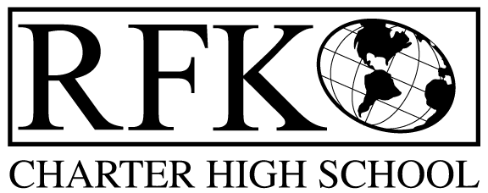

4300 Blake Rd. SW, Albuquerque, NM 87121

PHONE: 505-243-1118/FAX: 505-242-7444

Mission
RFK Charter School prepares, motivates, and supports students to achieve their college and career goals in partnership with their families and the community.

Governance Council Meeting Agenda

Thursday, May 19th, 2016 5:30pm

5 min Approval of Agenda

10 min Approval of April 2016 minutes

5 min Approval of January 2016 amended minutes

15 min Public Comment

30 min Finance Committee

March and April finance reports and approvals

cash disbursement approvals

BAR approval

5 min GC training update (Michelle)

5 min GC president update (Jennifer)

15 min student engagement report for AY 15-16

15 min Executive Director report (to include 2016-17 goals)

Adjournment

4300 Blake Rd. SW

Albuquerque, NM 87121

PHONE: 505-243-1118 FAX: 505-242-7444

PUBLIC NOTICE

OF

RFK GOVERNANCE COUNCIL

MEETING

Robert F. Kennedy Charter School will hold a regular meeting

of the Governance Council

Date

Thursday, May 19th, 2016

Time

5:30 pm

Location

RFK Charter School

4300 Blake SW

Albuquerque, NM

