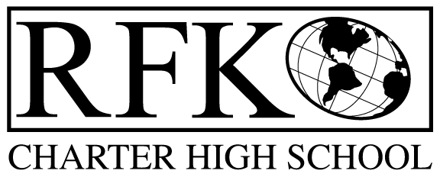

4300 Blake Rd. SW, Albuquerque, NM 87121
PHONE: 505-243-1118 FAX: 505-242-7444

Our Mission
The mission of Robert F. Kennedy Charter High School is to operate a public school that provides a safe, positive, supportive learning environment that considers each student’s individual learning style and level of skill development. Students will participate in an educational program with high expectations, mutual respect and community involvement that encourages and supports their mastery of the skills and knowledge required of high school graduates for the 21st century.

Governance Council Meeting Agenda
Date July 8, 2013 @ 5:30 pm

5 min Reading of RFK’s Mission Statement
5 min Approval of Agenda
30 min Review of mission statement
5 min Approval of previous meeting Minutes (April)
10 min Approval of Special Meeting Minutes (2)
10 min Public Forum
Committee Reports:
10 min Finance Report (March, April, May, June) and vote to approve
Vote on BAR(s)
30 min Policy and Procedures (Jennifer and Margie)
10 min Set new day and time for regular meetings starting in September
5 min RFK email update
10 min Executive Director Report (see attached)
10 min strategic planning debrief

Adjournment

4300 Blake Rd. SW
Albuquerque, NM 87121
PHONE: 505-243-1118 FAX: 505-242-7444

PUBLIC NOTICE
OF
GOVERNANCE COUNCIL
BOARD MEETING

Robert F. Kennedy Charter High School will be holding their monthly Governance Council Board Meeting.

Date
Monday, July 8, 2013

Time
5:30 pm

Location
4300 Blake Rd. SW
Albuquerque, NM 87121

