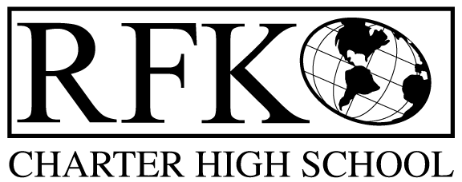

4300 Blake Rd. SW, Albuquerque, NM 87121

PHONE: 505-243-1118/FAX: 505-242-7444

Vision

“RFK, a school where you can engage in your chosen path towards secondary education or career in an environment that prepares, motivates, and supports you in partnership with your family.”

Mission

“This year we will improve teacher and student performance through a supportive and responsible environment.”

Governance Council Meeting Agenda

Thursday, January 21, 2016 5:30 pm

5 min Approval of Agenda

10 min Approval of December 2015 minutes

15 min Public Comment

15 min Finance Committee

December finance report and approval

cash disbursement approval

BAR approval

10 min Audit report and management response (Judy and Robert)

10 min vote on Ron Burton candidacy
10 min mission/vision statement rewording discussion and approval (Margie)

10 min training report (Michelle)

10 min NWEA report and credit acquisition report (Margie)

10 min Strategic Plan update (Margie)

15 min Legislative Finance Committee Report (Robert)

15 min Executive Director report

Adjournment

4300 Blake Rd. SW

Albuquerque, NM 87121

PHONE: 505-243-1118 FAX: 505-242-7444

PUBLIC NOTICE

OF

RFK GOVERNANCE COUNCIL

MEETING

Robert F. Kennedy Charter School will hold a regular meeting

of the Governance Council

Date

Thursday, January 21, 2016

Time

5:30 pm

Location

RFK Charter School

4300 Blake SW

Albuquerque, NM

