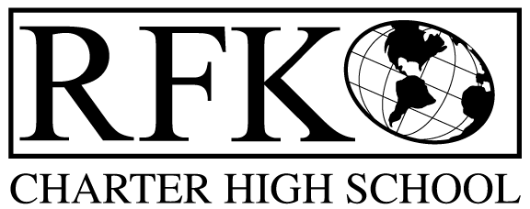

4300 Blake Rd. SW, Albuquerque, NM 87121

PHONE: 505-243-1118/FAX: 505-242-7444

Vision

“RFK, a school where you can engage in your chosen path towards secondary education or career in an environment that prepares, motivates, and supports you in partnership with your family.”

Mission

“This year we will improve teacher and student performance through a supportive and responsible environment.”

Governance Council Meeting Agenda

Thursday, December 17, 2015 5:30 pm

5 min Approval of Agenda

10 min Approval of November 2015 minutes

15 min Public Comment

15 min Finance Committee

November finance report and approval

cash disbursement approval

BAR approval

10 min reflection on Hugh Prather's training
10 min mission statement rewording discussion

15 min RFK internal policies and procedures, questions?

15 min Executive Director report

Adjournment

4300 Blake Rd. SW

Albuquerque, NM 87121

PHONE: 505-243-1118 FAX: 505-242-7444

PUBLIC NOTICE

OF

RFK GOVERNANCE COUNCIL

MEETING

Robert F. Kennedy Charter School will hold a regular meeting

of the Governance Council

Date

Thursday, December 17, 2015

Time

5:30 pm

Location

RFK Charter School

4300 Blake SW

Albuquerque, NM

