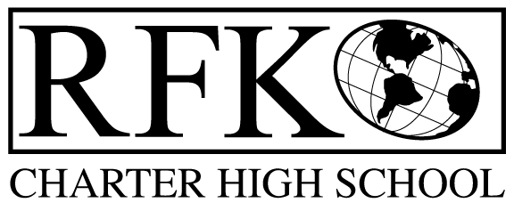

4300 Blake Rd. SW, Albuquerque, NM 87121

PHONE: 505-243-1118/FAX: 505-242-7444

Vision

“RFK, a school where you can engage in your chosen path towards secondary education or career in an environment that prepares, motivates, and supports you in partnership with your family.”

Mission

“This year we will improve teacher and student performance through a supportive and responsible environment.”

Governance Council Meeting Agenda

Wednesday, August 19, 2015, 6pm

5 min Approval of Agenda

10 min Approval of July 2015 minutes

15 min Public Comment: Cindy Mars, interested in membership, child development center

15 min Finance Committee

end of year finance report and approval

cash disbursement approval

BAR approval

10 min board training update

10 min vote on candidacy of Karl Smith
10 min Credit acquisition report (Margie)

5 min Review of mission and vision

10 min Board meeting calendar, vote to change or keep, how to publicize

10 min State Report Card review

10 min RFK educational offerings and graduation requirements approval vote

10 min Executive Director report

Adjournment

4300 Blake Rd. SW

Albuquerque, NM 87121

PHONE: 505-243-1118 FAX: 505-242-7444

PUBLIC NOTICE

OF

ANNUAL GOVERNANCE COUNCIL

MEETING

Robert F. Kennedy Charter School will hold the annual meeting

of it’s Governance Council

Date

Wednesday, August 19, 2015

Time

6 pm

Location

RFK Charter School

4300 Blake SW

Albuquerque, NM

