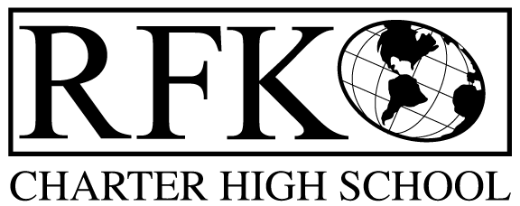

4300 Blake Rd. SW, Albuquerque, NM 87121

PHONE: 505-243-1118/FAX: 505-242-7444

Mission
RFK Charter School prepares, motivates, and supports students to achieve their college and career goals in partnership with their families and the community.

Governance Council Meeting Agenda

Thursday, March 17, 2016 6:00 pm

5 min Approval of Agenda

10 min Approval of February, 2016 minutes

15 min Public Comment

15 min Finance Committee

February finance report and approval

cash disbursement approval

BAR approval

15 min Executive Director report

Adjournment

4300 Blake Rd. SW

Albuquerque, NM 87121

PHONE: 505-243-1118 FAX: 505-242-7444

PUBLIC NOTICE

OF

RFK GOVERNANCE COUNCIL

MEETING

Robert F. Kennedy Charter School will hold a regular meeting

of the Governance Council

Date

Thursday, March 17, 2016

Time

6:00 pm

Location

RFK Charter School

4300 Blake SW

Albuquerque, NM

