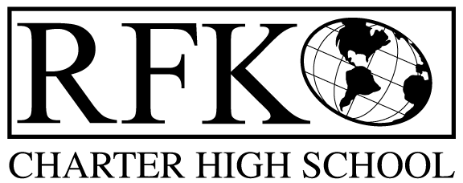

4300 Blake Rd. SW

Albuquerque, NM 87121

PHONE: 505-243-1118 FAX: 505-242-7444

Mission
RFK Charter School prepares, motivates, and supports students to achieve their college and career goals
in partnership with their families and the community.
Governance Council Meeting Agenda
Thursday, November 17, 2016, 5:30 pm

Time | Item | Presenter | Discussion/Action | Follow Up
5:30-5:35 | Approval of Agenda |  | Vote
5:35-5:45 | Dinner
5:45-5:50 | Approval of October, 2016 minutes |  | Vote
5:50-5:55 | Announcements |  | Discussion
5:55-6:10 | Public Comment |  | Discussion
6:10-6:30 | - Finance Committee Report, October finance discussion and approval  - Cash disbursement approval  - BAR(s) approval | Judy Bergs, Irene Sanchez  Judy Bergs, Irene Sanchez  Judy Bergs, Irene Sanchez | Vote  Vote  Vote
6:30-6:35 | Audit Report | Robert Baade | Discussion
6:35-6:50 | Committee Structure | Margie Lockwood | Discussion
6:50-7:05 | Executive Director Evaluation – final report | Margie Lockwood | Discussion
7:05-7:15 | New Mexico School Boards Association membership | Robert Baade | Discussion
7:15-7:30 | Property/Facilities | Robert Baade | Discussion
7:30-7:45 | Executive Director Report including legislative priorities discussion | Robert Baade | Discussion
7:45 | Adjournment |  | Vote

Next meeting: December 15, 2016

4300 Blake Rd. SW

Albuquerque, NM 87121

PHONE: 505-243-1118 FAX: 505-242-7444

PUBLIC NOTICE
OF
RFK GOVERNANCE COUNCIL
MEETING

Robert F. Kennedy Charter School will hold a regular meeting
of the Governance Council

Date
Thursday, November 17, 2016

Time
5:30 pm

Location
RFK Charter High School

4300 Blake Rd. SW
Albuquerque, NM

