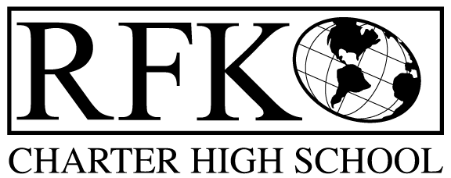

4300 Blake Rd. SW

Albuquerque, NM 87121

PHONE: 505-243-1118 FAX: 505-242-7444

Mission
RFK Charter School prepares, motivates, and supports students to achieve their college and career goals
in partnership with their families and the community.
Governance Council Meeting Agenda
Thursday, June 21, 2018 5:30 PM

Time | Item | Presenter | Discussion/Action | Follow Up
5:30-5:35 | Approval of agenda |  | Vote
5:35-5:40 | Approval of May 17, 2018 meeting minutes |  | Vote
5:40-5:45 | Announcements
5:45-6:00 | Public comment
6:00-6:30 | Website design – David Luft with LDD Consultants | Robert Baade,  David Luft
6:30-6:50 | - Finance Committee report for May– discussion and approval  - Cash disbursement approval  - BAR(s) approval | Irene Sanchez | Vote  Vote  Vote
6:50-7:30 | Closed session to conduct Executive Director’s annual evaluation and discuss contract | Margie Lockwood
7:30-7:35 | Executive Director’s contract renewal | Margie Lockwood | Vote
7:30-7:45 | Executive Director’s report | Robert Baade
7:45 | Adjourn

Next meeting: July 19, 2018

4300 Blake Rd. SW

Albuquerque, NM 87121

PHONE: 505-243-1118 FAX: 505-242-7444

PUBLIC NOTICE
OF
RFK GOVERNANCE COUNCIL MEETING
ANNUAL MEETING

Robert F. Kennedy Charter School will hold a regular meeting
of the Governance Council

Date
Thursday, June 21, 2018

Time
5:30 PM

Location
RFK Charter High School

4300 Blake Rd. SW
Albuquerque, NM

If you are an individual with a disability who is in need of a reader, amplifier, qualified sign language interpreter or any other form of auxiliary aid or service to attend or participate in the meeting, please contact the administrative offices of RFK High School at least one week prior to the meeting or as soon as possible. Public documents, including the agenda and minutes, can also be provided in various accessible formats.
RFK High School Administrative offices – 505-243-1118

