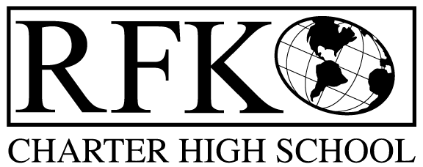

4300 Blake Rd. SW, Albuquerque, NM 87121

PHONE: 505-243-1118/FAX: 505-242-7444

Mission
RFK Charter School prepares, motivates, and supports students to achieve their college and

career goals in partnership with their families and the community.

Governance Council Meeting Agenda

Thursday, 06/16/2016 5:30 PM

5 min Approval of agenda

10 min Approval of May, 2016 minutes

10 min Public comment

20 min Teacher Effectiveness Report

15 min Finance Committee

May, 2016 finance report and approval

Cash disbursement approval

BAR approval

20 min Executive Session to discuss Executive Director evaluation and contract
5 min Executive Director contract renewal vote

20 min Discussion – AMAFCA issue, building on Bridge Blvd.

10 min Executive Director report

Adjournment

4300 Blake Rd. SW

Albuquerque, NM 87121

PHONE: 505-243-1118 FAX: 505-242-7444

PUBLIC NOTICE

OF

RFK GOVERNANCE COUNCIL

MEETING

Robert F. Kennedy Charter School will hold a regular meeting

of the Governance Council

Date

Thursday, June 16, 2016

Time

5:30 PM

Location

RFK Charter School

4300 Blake SW

Albuquerque, NM

