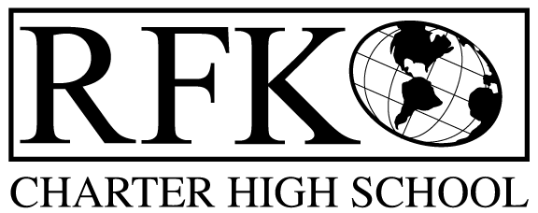

4300 Blake Rd. SW

Albuquerque, NM 87121

PHONE: 505-243-1118 FAX: 505-242-7444

PUBLIC NOTICE
OF
RFK GOVERNANCE COUNCIL MEETING

Robert F. Kennedy Charter School will hold a regular meeting
of the Governance Council

Date
Tuesday, January 21, 2020

Time
2:00 PM

Location
RFK Charter High School

4300 Blake Rd. SW
Albuquerque, NM

If you are an individual with a disability who is in need of a reader, amplifier, qualified sign language interpreter or any other form of auxiliary aid or service to attend or participate in the meeting, please contact the administrative offices of RFK High School at least one week prior to the meeting or as soon as possible. Public documents, including the agenda and minutes, can also be provided in various accessible formats.
RFK High School Administrative offices – 505-243-1118

4300 Blake Rd. SW

Albuquerque, NM 87121

PHONE: 505-243-1118 FAX: 505-242-7444

Mission
RFK Charter School prepares, motivates, and supports students to achieve their college and career goals
in partnership with their families and the community.
Governance Council Meeting Agenda
Tuesday, January 21, 2020
2:00 PM

Time | Item | Presenter | Discussion/Action | Follow Up
5 minutes | Approval of agenda | Tina Garcia | Vote
5 minutes | Approval December 12, 2019 meeting minutes | Tina Garcia | Vote
10 minutes | Public Comment
10 minutes | Middle School Update | Shawn Morris
15 minutes | Behavior & Discipline Report | Pete Ciurczak  Lawrence Torres
25 minutes | - Finance Committee report, cash disbursement for December, 2019– discussion and approval  - BAR(s) approval  - 2018/2019 Audit Report | Irene Sanchez | Vote  Vote  Vote
10 minutes | Strategic Plan – (asking for members) | Tina Garcia  Lawrence Barela | Discussion/Action
10 minutes | Executive Director’s report | Robert Baade
2 minutes | Adjourn | Tina Garcia | Vote

Next meeting: February 20, 2020

