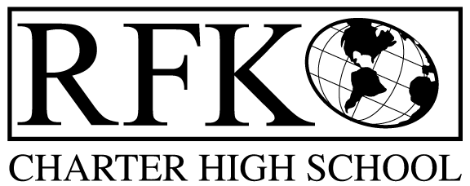
4300 Blake Rd. SW
Albuquerque, NM 87121
PHONE: 505-243-1118 FAX: 505-242-7444

Mission
RFK Charter School prepares, motivates, and supports students to achieve their college and career goals
in partnership with their families and the community.
Governance Council Meeting Minutes
Thursday, September 20, 2018, 5:30 PM

Governance Council Members present: Margie Lockwood, Sister Agnes Kaczmarek, Wendy Shanahan, Tina Garcia, Fernando Ortega, Ron Burton
Staff: Robert Baade, Irene Sanchez, Pete Ciurczak
Minutes by: Irene Sanchez

Sister Agnes Kaczmarek motioned to approve the agenda and Fernando Ortega seconds. Unanimously approved.
Fernando Ortega motioned to approve July 19, 2018 meeting minutes and Wendy Shanahan seconds. After spelling and word correction was made. The motion passed unanimously.
Announcements
- Fernando Ortega talked about current music, dance, art program being held at the Middle School.
  - Extracurricular activities with middle school students and community members. This will continue thru December.
- Fernando Ortega has resigned from the Governance Council to be more involved in the program at the middle school.
- Fernando Ortega introduced Ricardo Castillo as a possible board member.
- Colleen Gorman discussed Quote Unquote partnership with RFK.
Public Comment
- Robert Baade talked about Albuquerque Interfaith forum being held at RFK on September 23, 2018, 3:00pm – 5:00pm.

Attendance, behavior, retention report
- Pete Ciurczak discussed student behavior and attendance at RFK.
- Behavior
- Social media
- Attendance
- Bullying
- Controlled substances – alcohol and drugs
- Vape pens
- Fights

School grade, and 90 day improvement plan discussion
– Postponed until Linda Sanchez can present.

- Robert Baade discussed the ESL class.
- Margie Lockwood felt grade would improve based on reports throughout the year.

Finance Committee Report- August

Ron Burton motioned to approve the financial report for August 2018. Wendy Shanahan seconds. The motion passed unanimously.

Revenues
- No changes
- Available Operating Funds: $164,000.67

- Balance Sheet matches bank reconciliation: $66,476.53
- Difference is cash carryover

- Cash Disbursement Approval: $260,549.74

Ron Burton motioned to approve the cash disbursement and Wendy Shanahan seconds. Cash disbursement report is unanimously approved.
RFR
- Submitted through 8/31/18. Additional RFRs will be submitted after budget authority for the CSI grant received.
BAR(S)- BAR# 001-051-1819-0001-IB, Fund 24190 CSI Grant
Ron Burton motioned to approve the BAR# 001-051-1819-0001-IB and Wendy Shanahan seconds. BAR# 001-051-1819-0001-IB is unanimously approved.
Cash on hand –2.00 months of cash

Student Enrollment
- Current count is HS – 255, MS – 70, total is 325
- Projected enrollment 347 students
Audit Finding
- Only 1 finding
- Audit Committee will need to meet October 12 in the afternoon
Executive Directors Report
- We have received our school grade (F) and are beginning the process of analyzing the data
- Will be updating the 90 day turnaround plan to address areas of concern and opportunities for improvement. There will be a report on those changes at the next meeting and the full plan to be submitted to APS and PED.
- The budget remains strong with an eye toward the 40th day count and the calculation to determine if we are sending money back or gaining some. We are above our minimum projections and maintain a goal of 347 students enrolled on October 10th.
- The new portable at the middle school will be operational this month and APS has been a great partner in the effort. We have added a shade structure to the project, which will bring the total expenditure to over $100,000. The source of those funds is HB33 and has no impact on the operational budget.
- Requesting conversation and direction at the next two meetings regarding a legislative agenda.

Next meeting - October 18, 2018 5:30pm

Sister Agnes Kaczmarek moves to adjourn the meeting and Ron Burton seconds. The motion passed unanimously. Meeting adjourned at 7:46pm on September 20, 2018

Robert F Kennedy Charter School
Governance Council Meeting
9/20/2018

