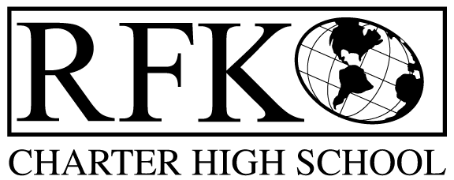

4300 Blake Rd. SW

Albuquerque, NM 87121

PHONE: 505-243-1118 FAX: 505-242-7444

Mission
RFK Charter School prepares, motivates, and supports students to achieve their college and career goals
in partnership with their families and the community.
Governance Council Meeting Minutes
Thursday, June 21, 2018, 5:30 PM

Governance Council Members present: Margie Lockwood, Ron Burton, Sister Agnes Kaczmarek, Katy Duhigg
Staff- Robert Baade, Irene Sanchez
Absent Wendy Shanahan, Tina Garcia, Fernando Ortega
Guest: David Luft, Martin Luke LDD Consultants
Minutes by: Anne Tafoya

Ron Burton motioned to approve the agenda and Katy Duhigg seconds. Unanimously approved. Will remove Executive Report from the agenda.
Ron Burton motioned to approve May 17, 2018 meeting minutes and Katy Duhigg seconds. The motion passed unanimously.
Announcements
- Introduction of Arleen Trujillo – Contracted with RFK for 1 year to work on the Stars Reporting, other duties- scheduling of students and transcripts
Public Comment N/A
Website design- David Luft with LDD Consultants (Martin Luke)
- Presenting the preliminary design of website
- Made some initial adjustments of look and color of the homepage of website
  - Added navigation bar- with drop down menu
  - Search functions
  - Key elements – quick links and portals
    - What is the Sunshine portal? Add information with hover – suggestion to rename it (Budget info/finance)
  - Call to action- and brief descriptions
  - Scrolling action
    - Can swap out content on the homepage- pictures, latest events
    - Side bar- can swap out content- latest news- dynamic
    - Calendar- user can subscribe-
    - Events Page
    - Footer will be on every page- quick links
    - Call out block- can add info or announcements here
    - Device adjustable-desktop, mobile, tablet
    - Not recommended to put secure information on the site-
      - Is okay to put the first page of the application
        - Have the option to add a PDF of the application that would be fill-out and printed
    - Will have a form that is “masked” when people want to email the Governance Council members
  - Next step is to approve the design

Finance Committee Report- May

Ron Burton motioned to approve financial committee report for May 2018. Sister Agnes Kaczmarek seconds. The motion passed unanimously

Revenues
  - No changes – just closing the Fiscal year out
- Available Operating Funds $ 29,257.47
    - Slightly higher than expected - projected carry over is $79,000
- Balance Sheet matches Bank reconciliation $276, 789.37
  - The amount matches
  - Bank reconciliation there are not differences
  - Can always view the bank statement – is attached monthly to financial report
- Cash Disbursement Approval- $362,450.44
  - Explanation of expenses was given
  - Some of the expenses are for the Kitchen
Ron Burton motioned to approve the cash disbursement and Sister Agnes Kaczmarek seconds. Cash disbursement report is unanimously approved.
RFR
- Submitted through May 31, 2018
- Irene will submit remaining RFR’s to close out the fiscal year
BAR(S)- 001-051-1718-0017-I SB-9
- Increase for SB-9 in the amount of $7,553.
Ron Burton moved to approve BAR # 001-051-1718-0017-I.Katy Duhigg seconds. The motion to pass the BAR is unanimous
Cash on hand –1.37
Student Enrollment
- 120 day- Student count 327
Audit Finding
- Only 1 finding

Sister Agnes Kaczmarek moved to approve the closed session to conduct Executive Director’s annual evaluation and discuss contract. Ron Burton seconds. The motion passed Unanimously.

Return to open meeting
At 7:06 PM Sister Agnes Kaczmarek moved to return to open meeting. Katy Duhigg seconds. Motion passed unanimously.

Executive Director’s Contract Renewal
Ron Burton moved to approve the Executive Director’s contract as written. Katy Duhigg seconds. Motion passed unanimously.

Adjourn
Katy Duhigg moved to adjourn. Sister Agnes Kaczmarek seconds. Motion passed unanimously.

Next meeting-, July 19, 2018 5:30-7:00

Robert F Kennedy Charter School
Governance Council Meeting
5/17/2018

