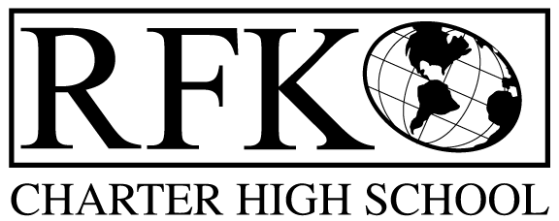

4300 Blake Rd. SW

Albuquerque, NM 87121

PHONE: 505-243-1118 FAX: 505-242-7444

Mission
RFK Charter School prepares, motivates, and supports students to achieve their college and career goals
in partnership with their families and the community.
Governance Council Meeting Minutes
Thursday, May 17, 2018, 5:30 PM

Governance Council Members present: Margie Lockwood, Wendy Shanahan, Fernando Ortega, Tina Garcia
Staff: Robert Baade, Irene Sanchez, Linda Ortega
Absent: Ron Burton, Sister Agnes Kaczmarek, Katy Duhigg
Guest: Lydia Muniz
Minutes by: Anne Tafoya

Wendy Shanahan motioned to approve the agenda and Fernando Ortega seconds. Unanimously approved. 3 corrections the Finance Committee report for April instead of March. Addition of proficiency requirements for Bilingual Seal, Dave Luft the website designer is not coming
Wendy Shananah motioned to approve April 19, 2018 meeting minutes and Tina Garcia seconds. The motion passed unanimously.
Announcements
- RFK made the top 40 places to work award
- May 25th 4:30 Graduation
Public Comment N/A

Bilingual Seal
- RFK has many students who are bilingual and would like a seal on their diploma
  - The Board need to assure PED that students are proficient and follow the requirements
  - Need units of credit and an assessment C or higher
  - Student may demonstrate proficiency by passing a NM assessment in a world language other than English.
  - They will have to pass course and PARCC
  - Will attain the services of a Bilingual Math Teacher
  - The seal will cost $400 per student who complete the requirements
  - The Board is aware that this will be added to the application

Finance Committee Report- April

Fernando Ortega motioned to approve financial report for April 2018. Wendy Shanahan seconds. The motion passed unanimously
Revenues
  - No changes – No BARS
- Available Operating Funds $ 45,769.60
  - Questions on unbudgeted expenses- Asking about the amount of carry over?
    - The amount is low but considering budget cuts it is good
- Balance Sheet matches Bank reconciliation $280,600.13
  - The amount matches
  - Bank reconciliation there are not differences
    - Committed for Summer Pay rolls
  - Can always view the bank statement – is attached monthly to financial report
- Cash Disbursement Approval- $295,850.98
  - Explanation of expenses was given
Wendy Shanahan motioned and Fernando Ortega seconds. Cash disbursement report is unanimously approved.
RFR
- Submitted through April 30, 2018
BARS- None
Cash on hand –1.3
Student Enrollment
- 120 day Student count 327
Audit
Only 1 finding for last year
- Disposal of assets
  - Flatbed trailer was stolen and needs to be disposed of properly
Fernando Ortega Motioned for the disposal of trailer and Tina Garcia seconds. The motion passed unanimously
Introduction of Lydia Muniz- Potential GC member
- Recommended Lydia Muniz as new GC member
- Degree in Higher Education, works at CNM emphasis is on Bilingual studies
- Robert invited Lydia to take a tour of the school

Executive Director’s Report –See attachment for full report
- Projected student counts to 347 – will add students to Middle School and Evening school
- Submitting $250,000 in Grant Proposals for next year’s funding
- Summer Institute scheduled for training teachers and new staff
- Interviewing for new teachers and staff members for outgoing staff
- Working at meeting Special Education Maintenance of Effort requirements for next year
  - Meeting this requirement will allow for additional Special Education Teachers
- Will start a DECA program
- Once graduation is over Robert will work on the Farm to School Project- needs some construction and maintenance
- Moving forward with a commitment by APS to install a cafeteria portable and have negotiated with APS to have breakfast and lunch by RFK staff in the kitchen

Next meeting-, June 21, 2018 5:30-7:00

Meeting Adjourn at 6:58 PM

Tina Garcia moves to adjourn the meeting and Wendy Shanahan seconds. The motion passed unanimously.

Robert F Kennedy Charter School
Governance Council Meeting
5/17/2018

