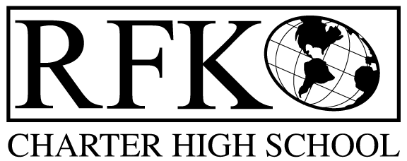

4300 Blake Rd. SW

Albuquerque, NM 87121

PHONE: 505-243-1118 FAX: 505-242-7444

Mission
RFK Charter School prepares, motivates, and supports students to achieve their college and career goals
in partnership with their families and the community.
Governance Council Meeting Agenda
Thursday, July 20, 2017, 5:30 PM

Governance Council Members: Sister Agnes Kaczmarek, Ron Burton, Fernando Ortega, and Tina Garcia
Staff: Robert Baade, Irene Sanchez, Pete Ciurczak, Linda Sanchez
Absent: Margie Lockwood, Michelle Felicia Renteria, and Jennifer Cornish

5:35 Tina Garcia motions to approve the agenda, Sister Agnes Kaczmarek seconds, unanimously approved.
5:44 Tina Garcia moves to approve June 15, 2017 meeting minutes, Fernando Ortega Seconds, unanimously approved.
- Edit for “Lottery” and “RFK”
- Note for closed session when ED evaluation was discussed.
5:50 Public Comment- Linda Sanchez
- PARCC Scores are in!
- Worked all year on common formative assessments- this year’s results are really good. We see real improvement.
- We met all of our goals this year.
- The common formative assessments really worked. This year we will be moving on to the Middle Schools. It requires level 3 and 4 type questions. It’s made by the teachers. Students become more accustomed to PARCC like questions.
- Teachers look at the data, they are able to see which students missed what questions. Scantron allows the teachers to generate a spreadsheet, so teachers don’t have to track data manually.
- Our students came all 3 days. We had only 5 make ups. This is a huge improvement as in the past a teacher would have to be designated just to do make ups.

6:05 Finance Report
- Revenues – No changes from last month
- Available operating funds are $125,522.13
- Carryover for the following funds are:
Instructional Materials - $3,176.44
Food Service - $17,752.36
IDEA-B - $9,389.84
ELA - $396.59
Training/Recruiting - $19,696.15

- Cash Disbursements were $629,391.75
- RFRs submitted thru 6/30/17
- NO BARs
- Months of cash on hand is 1.41
6:13 Sister Agnes Kaczmarek motion to approve the disbursements, Tina Garcia seconds, unanimously approved.
Ratification of ED Contract
- Payroll dates are wrong- must be corrected.
6:21 Sister Agnes Kaczmarek motions to approve the ratification of Robert’s contract, with the amended dates, Ron Burton seconds, unanimously approved.
6:24 ED Long Term Goals and Discussions (attachment)
Student engagement report
- Encouraging and supporting students to do well on accuplacer so they can dual enroll at CNM
- Robert has an interview with a licensed welding teacher- that would be an evening program.
- Culinary arts are in the schedule.
- Radio station is going on- there have been classes all summer not just for the RFK students but for the community.
- Co-ed Soccer will start in the Fall. Basketball and Volleyball will also be available.
- Currently assessing the need for Middle School sports.
- Electives- Guitar, Visual Arts, Ceramics, Fitness.
- Academics- college success for all the seniors, computer applications, intervention Thursdays (tutoring program…extra hour carved out for student specific tutoring)
- There is additional tutoring every Thursday and Wednesday between 3 and 4. Students can also access subject specific tutoring during this time.
- Language Arts teacher is moving from middle school, which allows current teacher to move to upper levels. Language classes will be split- 11th and 12th, then 9th and 10th
- Special Ed and Upper team will now have reading classes.
- Math Lab with Special Ed Licensed teacher
- Middle School- looking at biking in the Bosque. They currently like the activities at the west side community center.
- Anti-Gun Violence Non Profit in Santa Fe is going to come do a mural project. Students will be involved in the design.

7:26 Executive director report (attached)
7:27 Tina Garcia moves to adjourn, Sister Agnes Kaczmarek seconds, unanimously approved.

