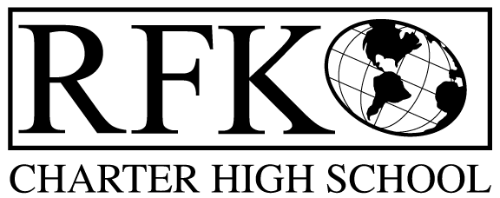

4300 Blake Rd. SW

Albuquerque, NM 87121

PHONE: 505-243-1118 FAX: 505-242-7444

Mission
RFK Charter School prepares, motivates, and supports students to achieve their college and career goals
in partnership with their families and the community.
Governance Council Meeting Agenda
Thursday, June 15, 2017, 5:30 PM

Governance Council Members: Margie Lockwood, Sister Agnes Kaczmarek, and Michelle Felicia Renteria, Jennifer Cornish, Ron Burton, Fernando Ortega, and Tina Garcia
Staff: Robert Baade and Irene Sanchez
Guests: Reyna Valencia

5:33 Ron Burton motioned to approve the agenda and Jennifer Cornish second. Unanimously approved.
5:44 Jennifer Cornish motioned to approve May 27, 2017 meeting minutes and Ron Burton second. Unanimously approved.
5:45 Announcements
- As of Wednesday RFL will be proud owners of a farm.
- Board Training available, National Charter School Resource Center and NMCCS www.nmccs.org
- Lotter Scholarship has been reduced- GC would like to start a scholarship fund for RFK students
5:52 Ron Burton motioned to approve Finance Committee report for May and Tina Garcia seconds. Unanimously approved.
5:55 Cash Disbursement Approval- 401,701.19 - Jennifer motioned and Ron Burton seconds. Unanimously approved.
5:57 Ron Burton motioned to approve BAR 27 I and Fernando Ortega second. Unanimously approved.
5:58 Ron Burton motioned to approve BAR 28 I and Jennifer Cornish second. Unanimously approved.
5:59 Ron Burton motioned to reelect Tina Garcia to Governance Council and Jennifer Cornish second. Unanimously approved.
6:03 Michelle Felicia Renteria motioned to approve Jennifer Cornish’s election to RFK GC Secretary Position and Tina Garcia second. Unanimously approved.
6:07 Program Review report discussion
- The final report from Steve Preskill and Karen Demoss is very positive
- One recommendation was co-teaching. This will foster more collaboration and continue peer learning
- Many comments on the report were similar to comments on the school surveys
- Build a youth leadership group for the upper team, every teacher has an advisory group- recommendation around engaging students in curriculum development
- Afterschool programs were also mentioned on the surveys, it is a work in progress
- How will the report impact the GC? Margie and Robert will begin going over current policy to make sure the recommendations align with our intended impact

6:24 ED Evaluation discussed
6:41 Goals for Next School Year
- Facilities Master Plan Project - last bond election Charter Schools get a portion of property taxes- through that house bill.
- Working with United Way for funding for Adult Education
- Margie working on long and short term goals. She will send to GC Board
- RFK will grow to 400 students in 2 years
- Common Formative Assessments – is helping teachers and instructors. It is also helping students on the PARC testing
- The Trauma Informed Care Training is funded for one more year
- Looking at grants for Welding and Auto Programs
7:02 Roberts Self-Assessment
- GC agrees the assessment is accurate
GC comments from Robert and Jennifer
Michelle Felicia Renteria motioned and Jennifer second. Unanimously approved.
7:34 Audit findings report
- Purchasing and procurement
- Payroll contributions- now have a payment schedule to make sure payments are on time. Now all of the reports are done before the 8th of the month
- Travel, per diem reimbursements, the rate was wrong. Irene will check the rates on the date
- Cash control Standards- finding were deposits were not done timely. Adding the desktop deposit has helped. To this date nothing has been deposited late.
- Purchasing in procurement - Irene monitors requisitions as they have come in.
7:44 Executive Director’s report (Attached)
- Funded Truancy Grant again this year, we had this in the current budget so that will free up some money for the operational budget.
7:47 Meeting Adjourn - Ron Burton moves to adjourn and Tina Garcia second. Unanimously approved.

