ROBERT F. KENNEDY CHARTER MIDDLE SCHOOL 6-8th grades
ENROLLING NOW FOR 2015-2016 SCHOOL YEAR
About RFK
Robert F. Kennedy Charter Middle School and High School offers a unique school experience for students seeking alternatives to traditional middle school and high school. Classes are small and students receive individual attention and interventions to academics. Tuition is free and RFK is open to students from anywhere in the state of New Mexico in grades 6-8th. All teachers are certified by the State of New Mexico and endorsed in their academic subject area.

Services and Programs for Students
- School Based Health Clinic
- Social Work/Family Services
- Music/Fine Arts
- College/Career Exploration
- Equine Therapy
- Philosophy of Experiential Education and Community Based Instruction Curriculum
- Camp Gallagher Experience: Hiking, Camping, Fishing in Jemez Mountains
- Trail Bicycling
- Martial Arts
- After school sports programs

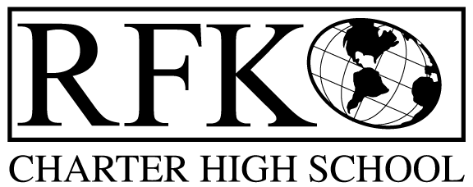

How to apply:
Walk in: 1021 Isleta Blvd., SW
8:00 am – 3:30 pm
or
Apply on line: www.rfkcharter.com
(select enrollment, complete form and submit your application)

For more information contact:
Cindy O’Niell,
Family and Student Support Officer
(505)243-1118 ext 61111 or (505) 321-4125

Robert F. Kennedy
Charter Middle School
1021 Isleta Blvd. SW
Albuquerque, NM 87105
Middle School - Office (505)877-4632
High School - Office: (505) 243-1118
www.rfkcharter.com

