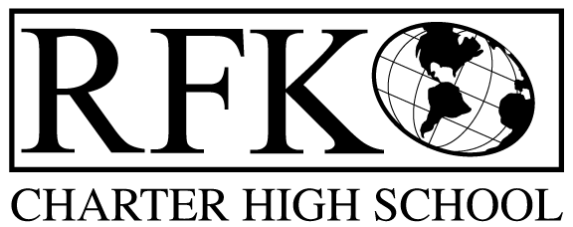

4300 Blake Rd. SW

Albuquerque, NM 87121

PHONE: 505-243-1118 FAX: 505-242-7444

PUBLIC NOTICE

OF

GOVERNANCE COUNCIL

MEETING

Robert F. Kennedy Charter School will hold a

regular monthly meeting of it’s Governance Council and Approval of Fiscal 2016 school year Budget

Date

Wednesday, April 22, 2015

Time

5:30 pm

Location

RFK Charter School

4300 Blake Road SW

Albuquerque, NM

