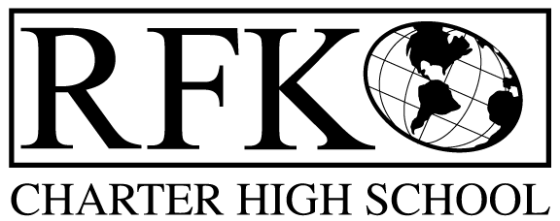

4300 Blake Rd. SW, Albuquerque, NM 87121

PHONE: 505-243-1118/FAX: 505-242-7444

Vision

“RFK, a school where you can engage in your chosen path towards secondary education or career in an environment that prepares, motivates, and supports you in partnership with your family.”

Mission

“This year we will improve teacher and student performance through a supportive and responsible environment.”

Governance Council Meeting Agenda

Thursday, September 17, 2015 6:00pm

5 min Approval of Agenda

10 min Approval of August 2015 minutes

10 min Public Comment

Child development center introduction

15 min Finance Committee

August finance report and approval vote

Cash disbursement approval vote

BAR approval vote

10 min Middle school transitions report (Tina)
10 min Credit acquisition report (Margie)

15 min Charter school renewal application review and vote

10 min State Report Card review

10 min Executive Director report

Adjournment

4300 Blake Rd. SW

Albuquerque, NM 87121

PHONE: 505-243-1118 FAX: 505-242-7444

PUBLIC NOTICE

OF

GOVERNANCE COUNCIL

MEETING

Robert F. Kennedy Charter School will hold a regular meeting

of its Governance Council

Date

Thursday, September 17, 2015

Time

6 pm

Location

RFK Charter School

4300 Blake SW

Albuquerque, NM

