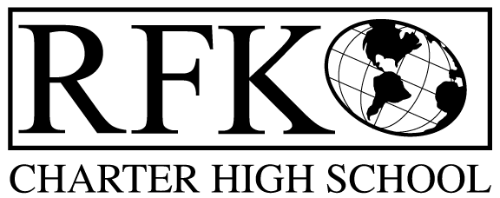

4300 Blake Rd. SW, Albuquerque, NM 87121

PHONE: 505-243-1118/FAX: 505-242-7444

Vision

“RFK, a school where you can engage in your chosen path towards secondary education or career in an environment that prepares, motivates, and supports you in partnership with your family.”

Mission

“This year we will improve teacher and student performance through a supportive and responsible environment.”

Governance Council Meeting Agenda

Thursday, October 15, 2015 5:30

5 min Approval of Agenda

10 min Approval of September 2015 minutes

15 min Public Comment

15 min Finance Committee

September finance report and approval

cash disbursement approval

BAR approval
5 min credit acquisition report follow up (Margie)

10 min charter school renewal application review (GC section only) and vote

20 min master plan proposal input (Ron)

10 min conflict of interest form discussion

10 min storage building purchase discussion

10 min mission and vision rewording and vote

10 min State Report Card review

10 min Executive Director report

Adjournment

4300 Blake Rd. SW

Albuquerque, NM 87121

PHONE: 505-243-1118 FAX: 505-242-7444

PUBLIC NOTICE

OF

REGULAR GOVERNANCE COUNCIL

MEETING

Robert F. Kennedy Charter School will hold a meeting

of it’s Governance Council

Date

Thursday, October 15, 2015

Time

5:30 pm

Location

RFK Charter School

4300 Blake SW

Albuquerque, NM

