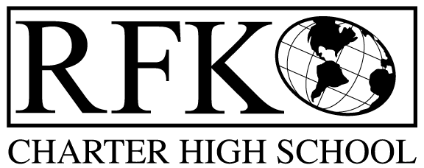

4300 Blake Rd. SW, Albuquerque, NM 87121

PHONE: 505-243-1118/FAX: 505-242-7444

Vision

“RFK, a school where you can engage in your chosen path towards secondary education or career in an environment that prepares, motivates, and supports you in partnership with your family.”

Mission

“This year we will improve teacher and student performance through a supportive and responsible environment.”

Governance Council Meeting Agenda

Wednesday, 19 November 2014, 5:30pm

5 min Approval of Agenda

10 min Approval of October 2014 minutes

15 min Public Comment

15 min vote on candidacy of Margie Lockwood and Michael Perez

20 min Finance Committee

October finance report and approval

Cash Disbursement approval

BAR approval

20 min program of study report and board input, Ivy Alford

15 min data report and quarterly retention report, Kenneth Lairesey

10 min LESC charter school meeting report - Margie

20 min strategic plan revision report

10 min Executive Director report

Adjournment

4300 Blake Rd. SW

Albuquerque, NM 87121

PHONE: 505-243-1118 FAX: 505-242-7444

PUBLIC NOTICE

OF

GOVERNANCE COUNCIL

MEETING

Robert F. Kennedy Charter School will hold a

regular monthly meeting of it’s Governance Council

Date

Wednesday, November 19, 2014

Time

5:30 pm

Location

RFK Charter School

4300 Blake Road SW

Albuquerque, NM

