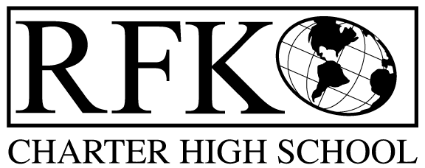

4300 Blake Rd. SW, Albuquerque, NM 87121

PHONE: 505-243-1118/FAX: 505-242-7444

Vision

“RFK, a school where you can engage in your chosen path towards secondary education or career in an environment that prepares, motivates, and supports you in partnership with your family.”

Mission

“This year we will improve teacher and student performance through a supportive and responsible environment.”

Governance Council Meeting Agenda

Wednesday, June 17, 2015 5:30

5 min Approval of Agenda

10 min Approval of May 2015 minutes

10 min Public Comment

15 min Finance Committee

finance report and approval

cash disbursement approval

BAR approval

10 min credit acquisition report (Margie, Cindy)

10 min teacher effectiveness report (Linda)

10 min strategic plan approval

15 min Executive Director evaluation

20 min Executive Director report

Adjournment

4300 Blake Rd. SW

Albuquerque, NM 87121

PHONE: 505-243-1118 FAX: 505-242-7444

PUBLIC NOTICE

OF

GOVERNANCE COUNCIL

MEETING

Robert F. Kennedy Charter School will hold a

regular monthly meeting of it’s Governance Council

Date

Wednesday, June 17, 2015

Time

5:30 pm

Location

RFK Charter School

4300 Blake SW

Albuquerque, NM

