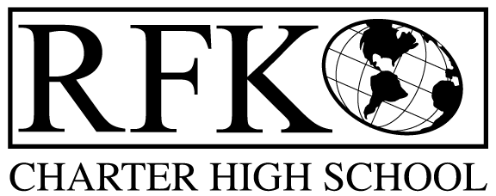
4300 Blake Rd. SW
Albuquerque, NM 87121
Phone-505-243-1118 / Fax: 505-242-7444

PARENT NOTIFICATION LETTER

(In Accordance with No Child Left Behind Act, Title 1, Part A, Section 1111,
Parent Right to Know/House Bill 212: 22-10A-16)

October 2, 2017

Dear Parent:

On January 8, 2002, President Bush signed the new federal education act, titled
No Child Left Behind. This new law includes many new programs and changes
for all public schools in the United States.

The new laws permit you, as a parent or guardian, the right to request information about the licensure and other qualifications, teaching assignment, and training of your child’s teacher and any paraprofessional (instructional assistants) who may work with your child.

If you are interested in requesting this information, please contact Robert Baade at (505) 243-1118.

Sincerely,

Raquel Reedy
Superintendent
Albuquerque Public Schools

