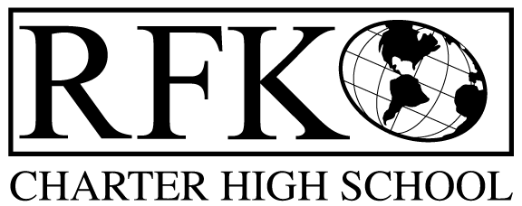

4300 Blake Rd. SW

Albuquerque, NM 87121

PHONE: 505-243-1118 FAX: 505-242-7444

PUBLIC NOTICE
OF
RFK GOVERNANCE COUNCIL
SPECIAL MEETING

Robert F. Kennedy Charter School will hold a special meeting
of the Governance Council

Date
Tuesday, November 22, 2016

Time
9:00 AM

Location
RFK Charter High School

4300 Blake Rd. SW
Albuquerque, NM

4300 Blake Rd. SW

Albuquerque, NM 87121

PHONE: 505-243-1118 FAX: 505-242-7444

Mission
RFK Charter School prepares, motivates, and supports students to achieve their college and career goals
in partnership with their families and the community.
Governance Council Special Meeting Agenda
Thursday, November 22, 2016, 9:00 AM

Time | Item | Presenter | Discussion/Action | Follow Up
9:00-9:05 | Approval of Agenda |  | Vote
9:05-9:10 | Approval of October 20, 2016 minutes |  | Vote
9:10-9:25 | Approval of BARs (see attached) | Irene Sanchez | Vote
9:20 | Adjournment |  | Vote

Next meeting: December 15, 2016

Robert F Kennedy Charter Governing Council
Finance Agenda
November 22, 2016

Bars for Approval –
  - 001-051-1617-0008-IB Hard to Staff Stipend
  - 001-051-1617-0009-I Fund 11000 Operational
  - 001-051-1617-0010-I Fund 14000 Instructional Materials
  - 001-051-1617-0011-I Fund 21000 Food Services
  - 001-051-1617-0012-I Fund 25153 Medicaid
  - 001-051-1617-0013-IB Fund 26163 Golden Apple Foundation
  - 001-051-1617-0014-IB Fund 29114 McCune Foundation
  - 001-051-1617-0015-I Fund 31600 HB-33
  - 001-051-1617-0017-I Fund 31701 SB-9 Local

