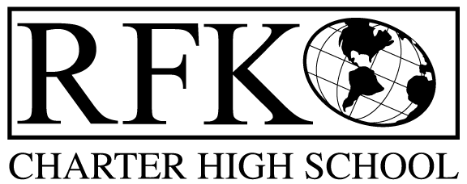

4300 Blake Rd. SW, Albuquerque, NM 87121

PHONE: 505-243-1118/FAX: 505-242-7444

Mission
RFK Charter School prepares, motivates, and supports students to achieve their college and career goals in partnership with their families and the community.

Governance Council Special Meeting Agenda

Monday, February 29, 2016 3:00 pm

5 min Approval of Agenda

15 min Public Comment

15 min Finance Committee – approval recommendation for

BAR approvals

2015-16 40th day final funded unit value adjustment

Cash carryover, JAG redistribution and HSTW Grant

Adjournment

4300 Blake Rd. SW

Albuquerque, NM 87121

PHONE: 505-243-1118 FAX: 505-242-7444

PUBLIC NOTICE

OF

RFK GOVERNANCE COUNCIL

SPECIAL MEETING

Robert F. Kennedy Charter School will hold a Special meeting

of the Governance Council

Date

Monday, February 29th, 2016

Time

3:00 pm

Location

Flying Star Cafe

4026 Rio Grande Blvd., NW

Albuquerque, NM 87107

