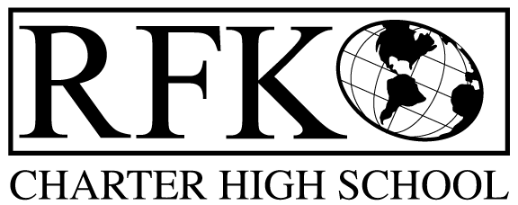

4300 Blake Rd. SW

Albuquerque, NM 87121

PHONE: 505-243-1118 FAX: 505-242-7444

Mission
RFK Charter School prepares, motivates, and supports students to achieve their college and career goals
in partnership with their families and the community.
Governance Council Meeting Agenda
Thursday, February 16, 2017, 5:30 PM

Time | Item | Presenter | Discussion/Action | Follow Up
5:30-5:35 | Approval of Agenda |  | Vote
5:35-5:45 | Dinner
5:45-5:50 | Approval of January 19, 2017 meeting minutes |  | Vote
5:50-5:55 | Announcements
5:55-6:10 | Public Comment
6:10-6:30 | - Finance Committee report for January – discussion and approval  - Cash disbursement approval  - BAR(s) approval | Irene Sanchez  Irene Sanchez  Irene Sanchez | Vote  Vote  Vote
6:30-6:45 | Governance Council membership consideration | Margie Lockwood | Vote
6:45-7:05 | Attendance, behavior, retention report | Pete Ciurczak
7:05-7:25 | Student engagement report | Lawrence Torres
7:25-7:45 | Executive Director’s report – including updates to goals | Robert Baade
7:45 | Adjournment

Next meeting: March 16, 2017

4300 Blake Rd. SW

Albuquerque, NM 87121

PHONE: 505-243-1118 FAX: 505-242-7444

PUBLIC NOTICE
OF
RFK GOVERNANCE COUNCIL MEETING

Robert F. Kennedy Charter School will hold a regular meeting
of the Governance Council

Date
Thursday, February 16, 2017

Time
5:30 PM

Location
RFK Charter High School

4300 Blake Rd. SW
Albuquerque, NM

If you are an individual with a disability who is in need of a reader, amplifier, qualified sign language interpreter or any other form of auxiliary aid or service to attend or participate in the meeting, please contact the administrative offices of RFK High School at least one week prior to the meeting or as soon as possible. Public documents, including the agenda and minutes, can also be provided in various accessible formats.
RFK High School Administrative offices – 505-243-1118

