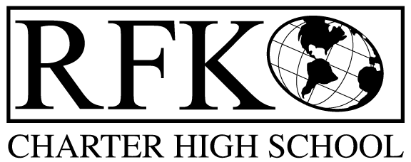

4300 Blake Rd. SW

Albuquerque, NM 87121

PHONE: 505-243-1118 FAX: 505-242-7444

Mission
RFK Charter School prepares, motivates, and supports students to achieve their college and career goals
in partnership with their families and the community.
Governance Council Special Meeting Agenda
Thursday, November 22, 2016, 9:00 AM

Time | Item | Presenter | Discussion/Action | Follow Up
9:00-9:05 | Approval of Agenda |  | Vote
9:05-9:20 | Approval of BARs | Irene Sanchez | Vote
9:20 | Adjournment |  | Vote

Next meeting: December 15, 2016

4300 Blake Rd. SW

Albuquerque, NM 87121

PHONE: 505-243-1118 FAX: 505-242-7444

PUBLIC NOTICE
OF
RFK GOVERNANCE COUNCIL
SPECIAL MEETING

Robert F. Kennedy Charter School will hold a special meeting
of the Governance Council

Date
Tuesday, November 22, 2016

Time
9:00 AM

Location
RFK Charter High School

4300 Blake Rd. SW
Albuquerque, NM

