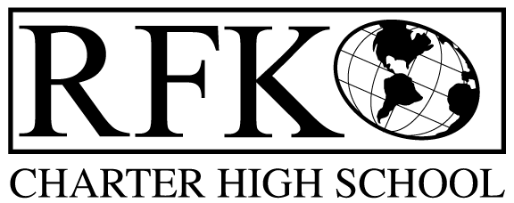

4300 Blake Rd. SW

Albuquerque, NM 87121

PHONE: 505-243-1118 FAX: 505-242-7444

Mission
RFK Charter School prepares, motivates, and supports students to achieve their college and career goals
in partnership with their families and the community.
Governance Council Meeting Agenda
Thursday, November 16, 2017, 5:30 PM

Time | Item | Presenter | Discussion/Action | Follow Up
5:30-5:35 | Approval of agenda |  | Vote
5:35-5:40 | Approval of October 19, 2017 meeting minutes |  | Vote
5:40-5:45 | Announcements
5:45-6:00 | Public comment
6:00-6:20 | - Finance Committee report for October – discussion and approval  - Cash disbursement approval  - BAR(s) approval  - Financial Health report | Irene Sanchez | Vote  Vote  Vote
6:20-6:35 | Election of Katy Duhigg to GC |  | Vote
6:35-6:40 | Legislative priorities
6:40-6:55 | Closed session to discuss 2016-17 audit report | Margie Lockwood
6:55-7:00 | GC Training | Margie Lockwood
7:00-7:10 | Review of GC Effectiveness Evaluation results | Margie Lockwood
7:10-7:25 | Executive Director’s report | Robert Baade
7:25 | Adjourn |  | Vote

Next meeting: December 21, 2017
Thanksgiving break: November 22 – 24
Winter break: December 18 – January 1

4300 Blake Rd. SW

Albuquerque, NM 87121

PHONE: 505-243-1118 FAX: 505-242-7444

PUBLIC NOTICE
OF
RFK GOVERNANCE COUNCIL MEETING
ANNUAL MEETING

Robert F. Kennedy Charter School will hold a regular meeting
of the Governance Council

Date
Thursday, November 16, 2017

Time
5:30 PM

Location
RFK Charter High School

4300 Blake Rd. SW
Albuquerque, NM

If you are an individual with a disability who is in need of a reader, amplifier, qualified sign language interpreter or any other form of auxiliary aid or service to attend or participate in the meeting, please contact the administrative offices of RFK High School at least one week prior to the meeting or as soon as possible. Public documents, including the agenda and minutes, can also be provided in various accessible formats.
RFK High School Administrative offices – 505-243-1118

